**cWindows Server 2016 installation requirements**

minimum system requirements apply to all installation options (Server Core, Server with Desktop Experience, and Nano Server) and both the Standard and Datacenter Editions of Windows Server 2016.

Processor:

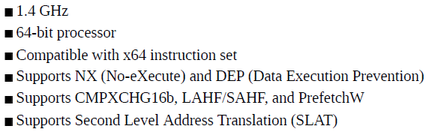

Ram:

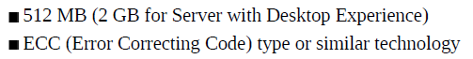

Storage controllers and disk space:



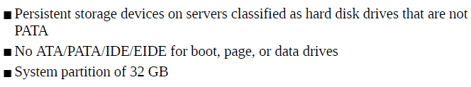

Network adapter

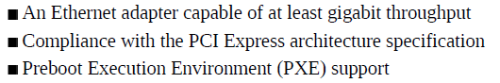

Ethernet 1gigabit

**EDITIONS COMPARISON**

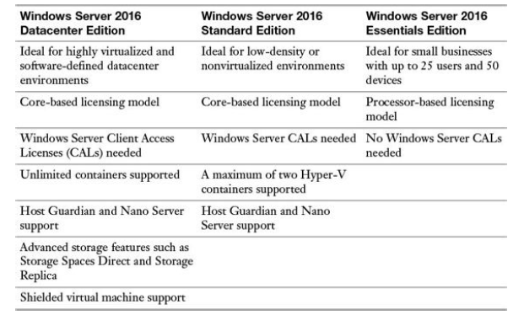

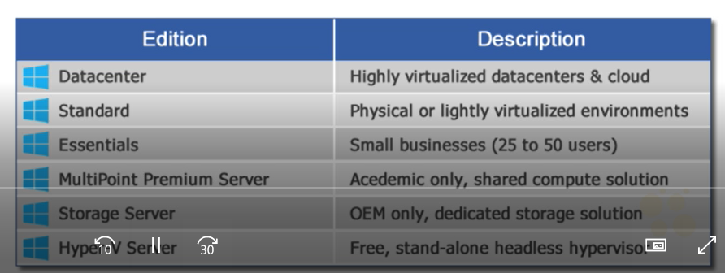

Standard edition> VM&Container to support (2)

Datacenter> storage replica, storage space direct, shielded VM

License every single core in server>> min 8 core licenses per physical CPU (min 16core licences per server)

Workload>> server roles and feature

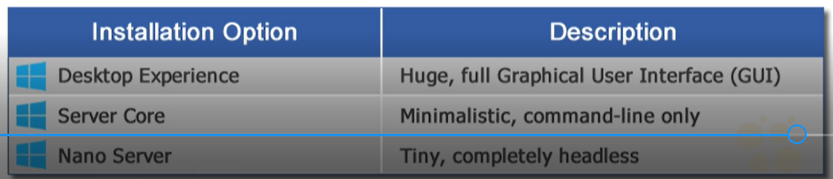

**Windows PowerShell Desired State Configuration (DSC)**

* Script the intended configuration of Windows Server
* Configure server
* Restore server settings

**Upgrade & Migrations**

**Upgrade**

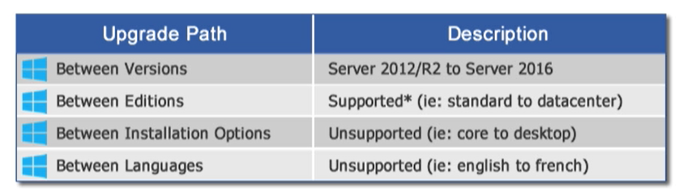

Clean installation, migration, cluster OS rolling upgrade, License conversion, upgrade

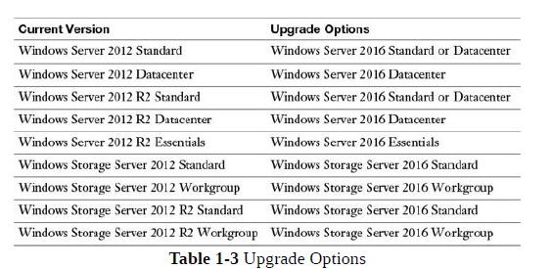

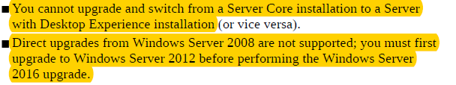

**Migration**

(2016server üzerinde)

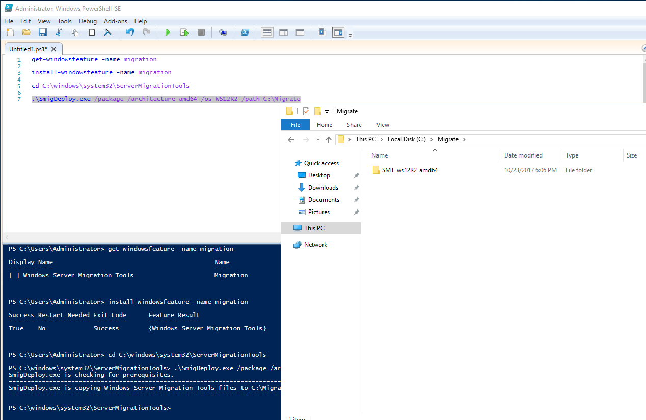

2012 server üzerinde

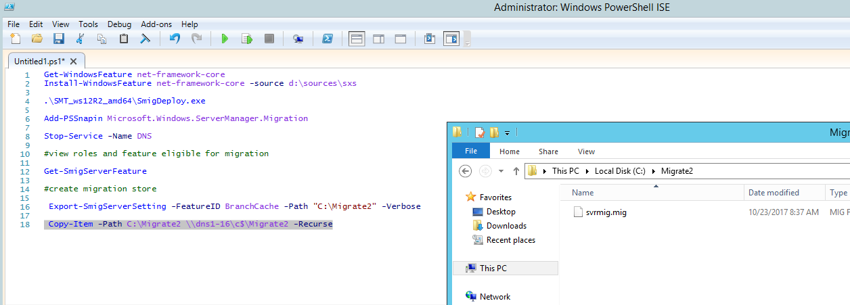

(2016server üzerinde)

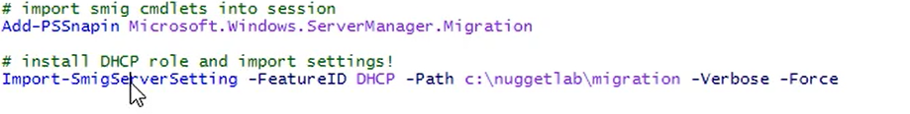

.mig dosyasının oldugu klasör import edilir

**Activation Model**

**AVMA (automatic virtual machine activation) >>** slmgr /ipk <productkey> ; slmgr/ato



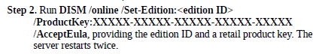

**KMS>>** 180günlük aktivasyon sağlar (add Volume Activation Service)

**AD based activation>>** server2012 or up ; client win8 or up (add Volume Activation Service)

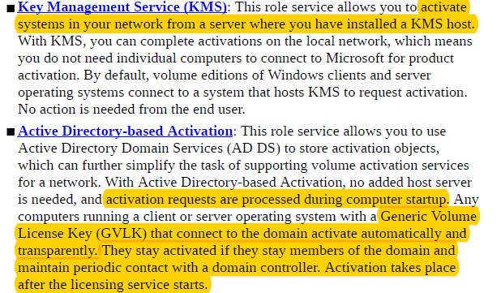

Server Core

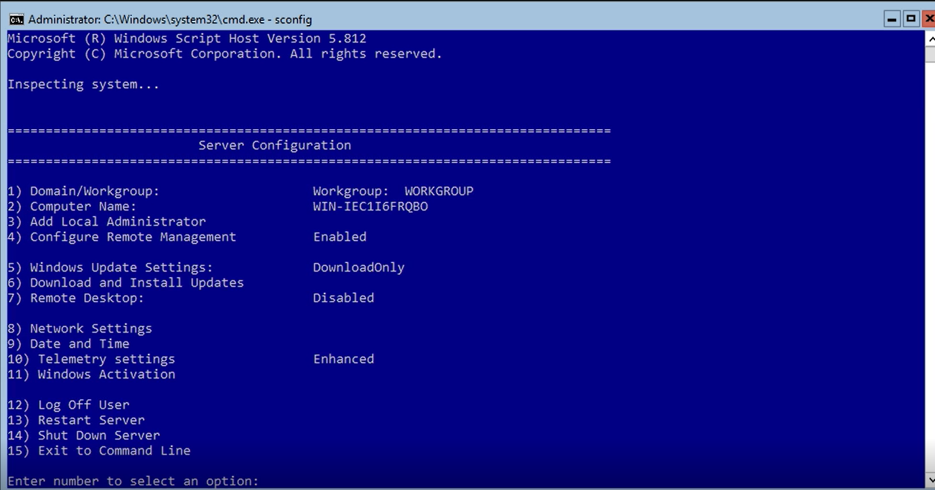

Cmd> start powershell

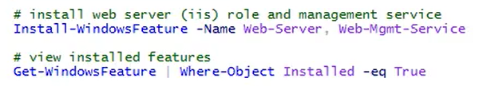

**POWERSHELL DESIRED STATE CONFIGURATION**

* Configuration-implementation
* Avoids configuration drift

Requirements

* Enable winRM on systems you want to manage by DSC

Configuration block+node block

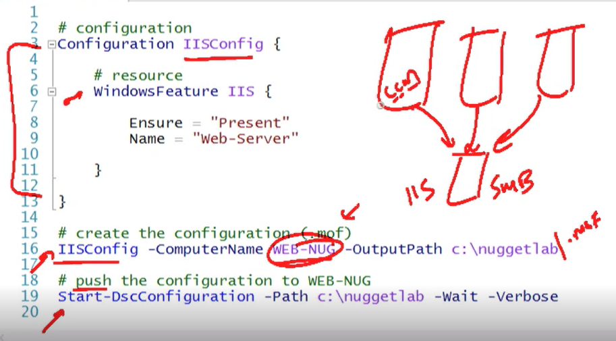

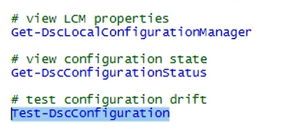

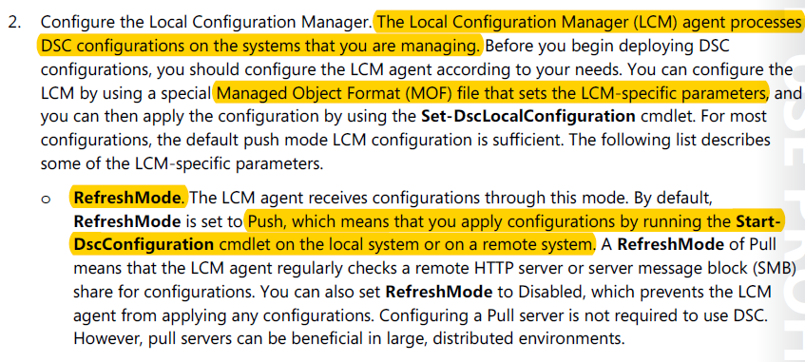

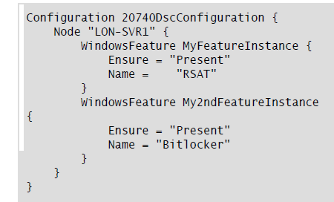

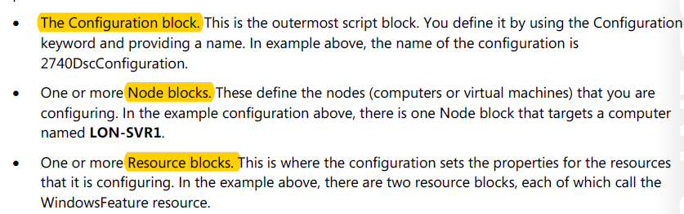

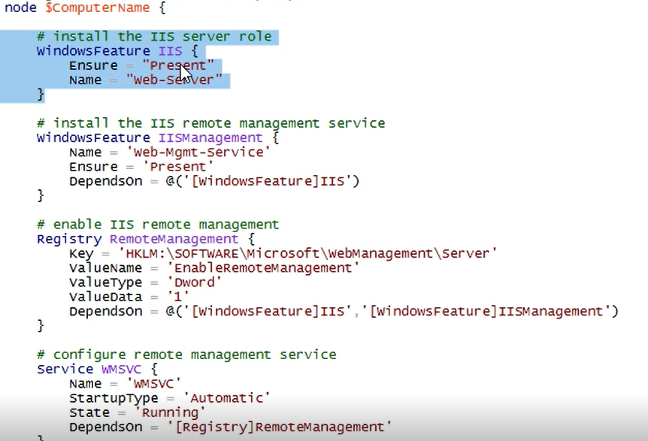

**Install and configure Nano Server**

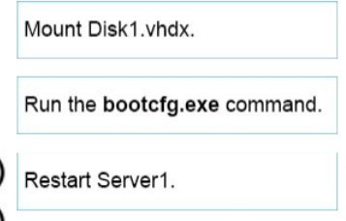

feature

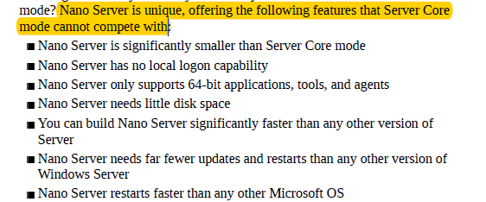

usage

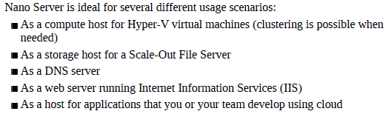

notes

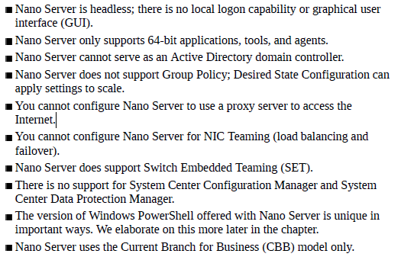

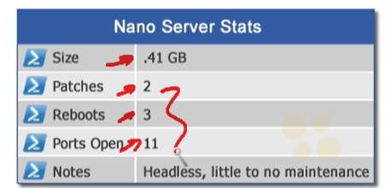

Has powershell core version

Supports Desired State Configuration

Creating NanoServer

#give path from srver2016 iso disk

Import-Module D:\NanoServer\NanoServerImageGenerator -Verbose

New-NanoServerImage -MediaPath D: -BasePath C:\NanoServer2\Base -TargetPath C:\NanoServer2\nanosrv2.vhdx -DeploymentType Guest -Edition Datacenter -ComputerName nanosrv2 -InterfaceNameOrIndex Ethernet -Ipv4Address 192.168.1.55 -Ipv4SubnetMask 255.255.255.0 -Ipv4Gateway 192.168.1.1 -Ipv4Dns 192.168.1.2 -Package Microsoft-NanoServer-IIS-Package

Managing Nanoserver remotely using powershell

#give path from srver2016 iso disk

Import-Module D:\NanoServer\NanoServerImageGenerator -Verbose

#creating nanoserver vhdx

New-NanoServerImage -MediaPath D: -BasePath C:\NanoServer1\Base -TargetPath C:\NanoServer1\nanosrv.vhdx -DeploymentType Guest -Edition Datacenter -ComputerName nanosrv1

#getting available nanoserver packages

Get-NanoserverPackage -MediaPath D:

#creating nanoserver vhdx with packages and network settings

New-NanoServerImage -MediaPath D: -BasePath C:\NanoServer2\Base -TargetPath C:\NanoServer2\nanosrv2.vhdx -DeploymentType Guest -Edition Datacenter -ComputerName nanosrv2 -InterfaceNameOrIndex Ethernet -Ipv4Address 192.168.1.55 -Ipv4SubnetMask 255.255.255.0 -Ipv4Gateway 192.168.1.1 -Ipv4Dns 192.168.1.2 -Package Microsoft-NanoServer-IIS-Package

New-NanoServerImage -MediaPath D: -BasePath C:\NanoServer3\Base -TargetPath C:\NanoServer3\nanosrv3.vhdx -DeploymentType Host -Edition Datacenter -ComputerName nanosrv3 -InterfaceNameOrIndex Ethernet -Ipv4Address 192.168.1.60 -Ipv4SubnetMask 255.255.255.0 -Ipv4Gateway 192.168.1.1 -Ipv4Dns 192.168.1.2 -Package Microsoft-NanoServer-IIS-Package

#view installed packages

Get-WindowsPackageOnline

#add nanoserver to trusted hosts of local machine for winrm

Set-item WSMan:\localhost\Client\TrustedHosts "192.168.1.55"

#connecting to nanoserver

Enter-PSSession -ComputerName 192.168.1.55 -Credential (Get-Credential)

$nanosession= New-PSSession -ComputerName 192.168.1.55 -Credential (Get-Credential)

#offline domain join prestage (on DC)

djoin.exe --% /provision /domain yigitaydog.local /machine nanosrv1 /savefile C:\Djoin\Djoin.txt

#copy txt to nanoserver

Copy-Item C:\Djoin\Djoin.txt -Destination C:\ -ToSession $nanosession

Enter-PSSession -ComputerName 192.168.1.55 -Credential (Get-Credential)

#offline domain join prestage (on nanoserver)

djoin.exe --% /requestodj /loadfile C:\Djoin.txt /windowspath c:\windows /localos

Restart-Computer;exit

Package management (nano)

Get-Module -ListAvailable -Name PackageManagement

#finding providers available online

Find-PackageProvider

# install available provider

Install-PackageProvider NanoServerPackage

#finding commands in provider

get-command -Module NanoServerPackage

#list all packages from one provider

Find-Package -Providername NanoServerPackage

#import provider

import-PackageProvider NanoServerPackage

#install a package

Install-Package -name Microsoft-NanoServer-IIS-Package

#find installed a packages

Get-Package

hyperV package for nanoserver >>



Save-NanoServerPackage -Name Microsoft-NanoServer-DNS-Package -Path C:\

Plan for Windows Server virtualization

benefits

**Lack of hardware driver issues:**

smaller physical space, lower power costs, and reduced cooling requirements

distribute resources to virtual machines as demand

easy to deploy new servers

operational efficiency

reduced maintenance

cloud integration

lab testing

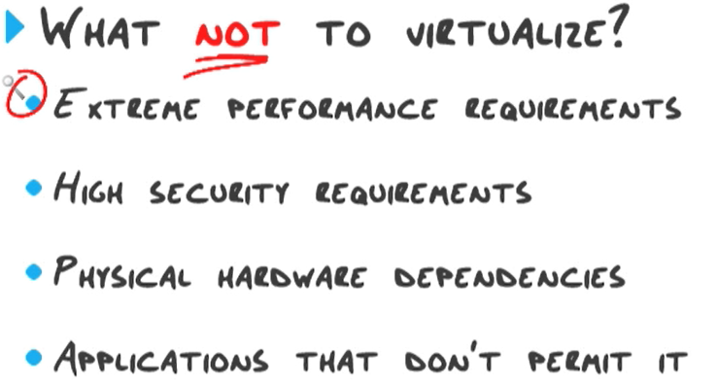

licensing requirement, high I/0 necessity

security for host> keep OS host secure, limit use of host, patching, do not mount uknown VHD,

security for VM> enable secure boot, secure guest OS, secure network, keep hard disk and snapshots in secure place

Generation2 VM

Secure boot, PXE boot and boot from vhdx

64bit OS needed

Can not be used in Azure Migrations

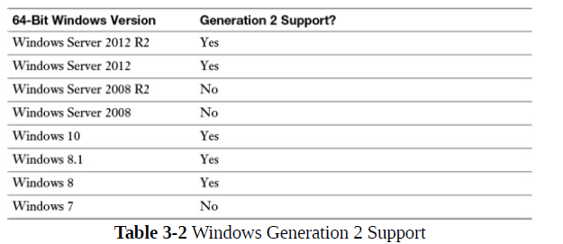

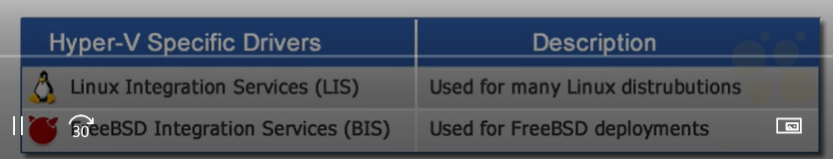

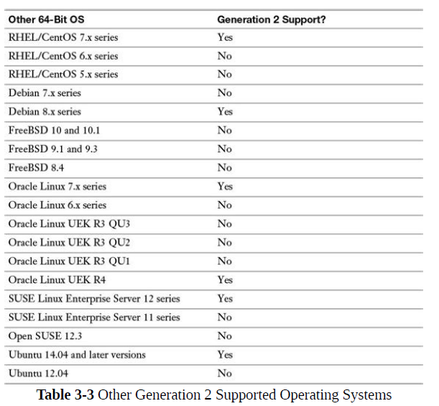

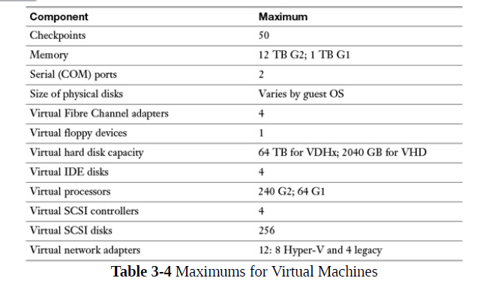

Microsoft Assessment and Planning (MAP)

WMI ile diğer bilgisayardan bilgi çeker, database’e kaydeder

Agentless, multi product

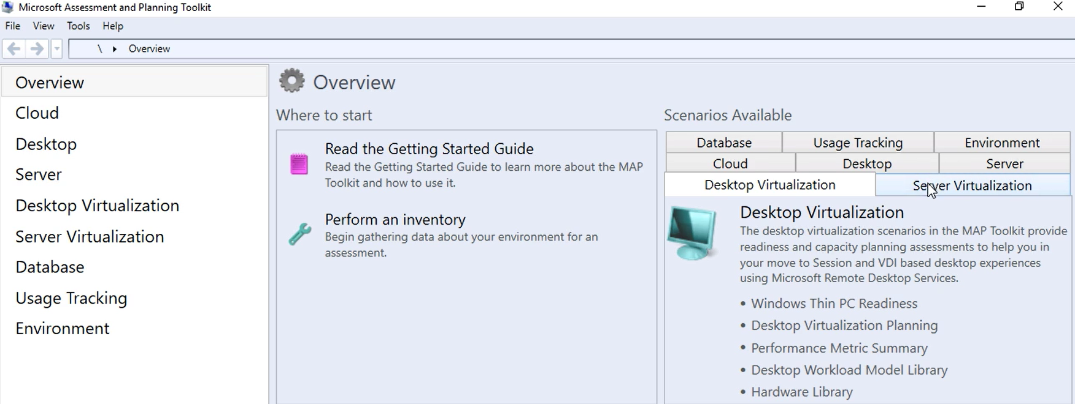

Perform an inventory> select machine OS, search method (AD DS, Scan IP range, SCCM, computername and credential), search credential

Collect performance metrics of found machines

considerations for deploying workloads into virtualized environments

VM rescource requirments> processor, network, storage, memory, downtime, encryption

Workload characteristics> stateless, shared stateful

VM configurations> generation type, dynamic/static memory assignment, processor assignment, storage

Host planing> resource, location, and same as VM configuration

Architecture and Capability planning> start up cost, maintanance domain

update images with patches, hotfixes, and drivers

### #view images within a .wim

Dism /get-imageinfo /imagefile:C:\Images\install.wim

#mount servercore datacenter image

Dism /mount-image /imagefile: C:\Images\install.wim /index:3 /mountdir:C:\mount

#add drivers

Dism / image: C:\mount /add-driver /driver: C:\Drivers \recurse

Dism / image: C:\mount /remove-driver /driver: C:\Drivers\drivername.inf

#add patch,update,hotfix



#add roles and features

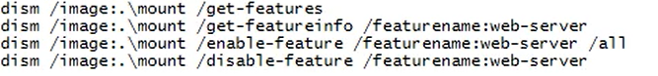



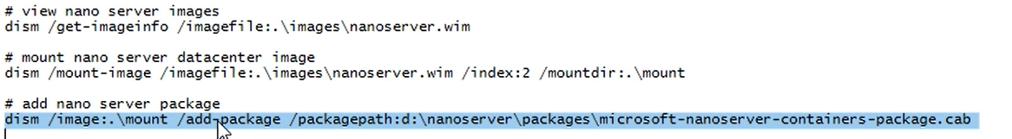

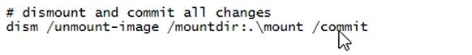

Commit or discard

Powershell version

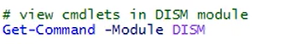

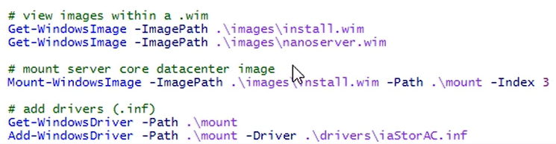

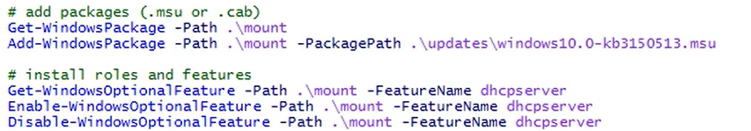

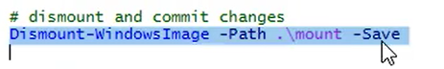

manage and maintain VHDs

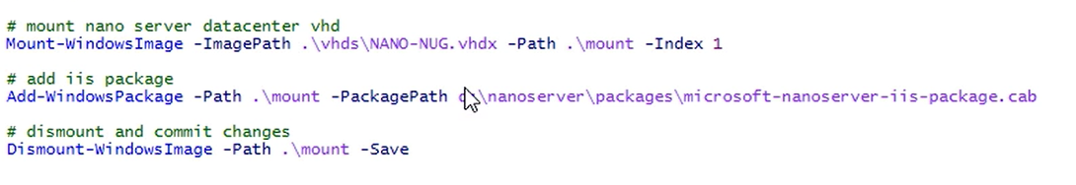

|  |  |
| --- | --- |
| **Dism.exe command** | **DISM cmdlet** |
| Dism.exe /Append-Image | Add-WindowsImage |
| Dism.exe /Apply-Image | Expand-WindowsImage |
| Dism.exe /Capture-Image | New-WindowsImage |
| Dism.exe /Cleanup-MountPoints | Clear-WindowsCorruptMountPoint |
| Dism.exe /Commit-Image | Save-WindowsImage |
| Dism.exe /Export-Image | Export-WindowsImage |
| Dism.exe /Get-ImageInfo | Get-WindowsImage |
| Dism.exe /Get-MountedImageInfo | Get-WindowsImage -Mounted |
| Dism.exe /Get-WimBootEntry | Get-WIMBootEntry |
| Dism.exe /List-Image | Get-WindowsImageContent |
| Dism.exe /Mount-Image | Mount-WindowsImage |
| Dism.exe /Split-Image | Split-WindowsImage |
| Dism.exe /Remove-Image | Remove-WindowsImage |
| Dism.exe /Remount-Image | Mount-WindowsImage -Remount |
| Dism.exe /Unmount-Image | Dismount-WindowsImage |
| Dism.exe /Update-WimBootEntry | Update-WIMBootEntry |
| Dism.exe /Image:<…> /Add-Driver | Add-WindowsDriver |
| Dism.exe /Image:<...> /Add-Package | Add-WindowsPackage |
| Dism.exe /Image:<...> /Add-ProvisionedAppxPackage | Add-AppxProvisionedPackage |
| Dism.exe /Image:<...> /Apply-Unattend | Apply-WindowsUnattend |
| Dism.exe /Image:<...> /Cleanup-Image /CheckHealth | Repair-WindowsImage -CheckHealth |
| Dism.exe /Image:<...> /Cleanup-Image /ScanHealth | Repair-WindowsImage –ScanHealth |
| Dism.exe /Image:<...> /Cleanup-Image /RestoreHealth | Repair-WindowsImage –RestoreHealth |
| Dism.exe /Image:<...> /Disable-Feature | Disable-WindowsOptionalFeature |
| Dism.exe /Image:<...> /Enable-Feature | Enable-WindowsOptionalFeature |
| Dism.exe /Image:<...> /Export-Driver | Export-WindowsDriver |
| Dism.exe /Image:<...> /Get-CurrentEdition | Get-WindowsEdition -Current |
| Dism.exe /Image:<...> /Get-Driverinfo | Get-WindowsDriver -Driver |
| Dism.exe /Image:<...> /Get-Drivers | Get-WindowsDriver |
| Dism.exe /Image:<...> /Get-Featureinfo | Get-WindowsOptionalFeature -FeatureName |
| Dism.exe /Image:<...> /Get-Features | Get-WindowsOptionalFeature |
| Dism.exe /Image:<...> /Get-Packageinfo | Get-WindowsPackage -PackagePath | -PackageName |
| Dism.exe /Image:<...> /Get-Packages | Get-WindowsPackage |
| Dism.exe /Image:<...> /Get-ProvisionedAppxPackages | Get-AppxProvisionedPackage |
| Dism.exe /Image:<...> /Get-TargetEditions | Get-WindowsEdition -Target |
| Dism.exe /Image:<...> /Optimize-Image | Optimize-WindowsImage |
| Dism.exe /Image:<...> /Remove-Driver | Remove-WindowsDriver |
| Dism.exe /Image:<...> /Remove-Package | Remove-WindowsPackage |
| Dism.exe /Image:<...> /Remove-ProvisionedAppxPackage | Remove-AppxProvisionedPackage |
| Dism.exe /Image:<...> /Set-Edition | Set-WindowsEdition |
| Dism.exe /Image:<...> /Set-ProductKey | Set-WindowsProductKey |
| Dism.exe /Image:<...> /Set-ProvisionedAppxDataFile | Set-AppXProvisionedDataFile |

**Configure disks and volumes**

Allocation unit size=cluster size >> smallest amount of space that can be used to hold a file

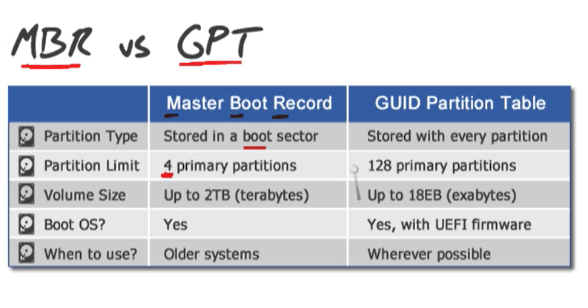

Sector Size

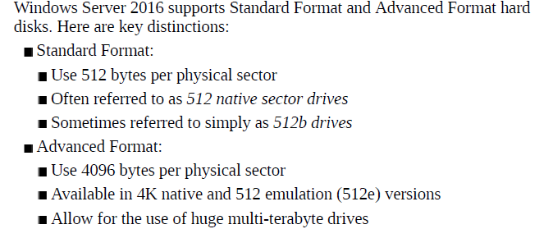

**fsutil fsinfo sectorinfo c:**

**REFS & NTFS**

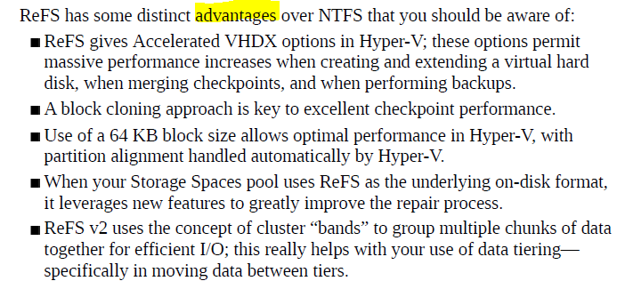

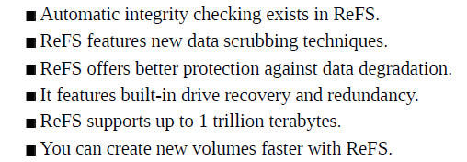

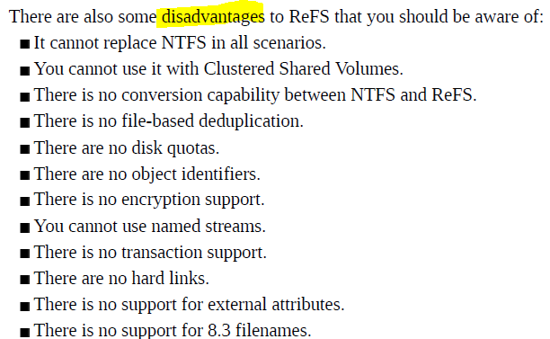

Disk I/O hızları küçükten büyüğe:

EIDE (enhanced Integrated Drive Electronics), SATA (Serial Advanced Technology Attachment), SCSI (Small Computer System Interface), NL-SAS, SAS, SAS-SSD

Yönetim: cmd üzerinden diskpart

List disk / List volume

Seleck disk <diskno>

List partition

Clean>> completely remove data on disk

Create partition primary size <sizenumber in mb>

**Basic disk** >> partition (volume) harflerle gösterilir

3primary partition (işletim sisteminin açılış yapabildiği bölüm)+1extended partition(data depolamasında kullanılır) yada 4primary partition

Sadece 1 tane aktif primary partition olabilir.

**Powershell komutları**

Mevcuttaki disklerin durumu

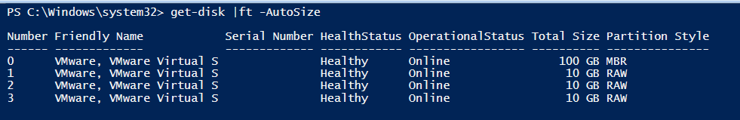

Initialize olmayan diskleri initialize eder

Get-disk | where PartitionStyle –eq ‘raw’ | initialize-disk –PartitionStyle MBR

Bu işlemlerden sonra diskler basic disk olarak yapılandırılır

initialize-disk –number 0 –PartitionStyle MBR

Işletim sistemi kurulu olan diski bulmak

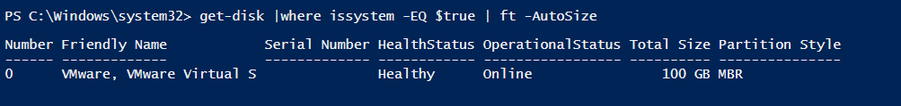

Disklerdeki partition durumunu sorgulamak

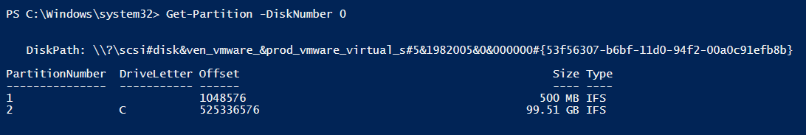

(Basic diskte)

Yeni partition oluşuturup formatlamak ve kaldırmak

New-Partition –Size 1GB(or –UseMaximumSize) –Disknumber 1 –DriveLetter E

Format-Volume –DriveLetter E –Confirm –Compress –FileSystem NTFS –NewFileSystemLabel “BasicDiskPart1” –AllocationUnitSize 4096

Remove-Partition –Disknumber1 –Partitionnumber 2

(Basic diskte)

Oluşturulan volume’ler ile ilgili bilgi almak

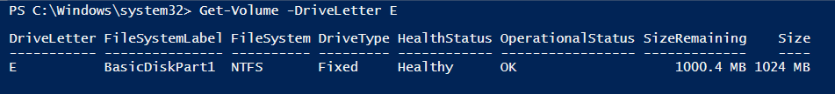

**Dynamic disk**

Farklı diskler üzerindeki volume’leri tek bir sürücü harfi altında birleştirilebilir

Volume boyutları büyütülebilir

Partition’lar repair edilebilir

Dynamic to basic convertion deletes data

Basic to dynamic does not delete data

Simple volume, spanned volume, striped volume, mirrored volume, RAID5 volume

* Spanned: en az 2diske ihtiyaç var (kullanılmamış alanlardan). Farklı diskler üzerindeki boş alanları bileştirerek tek bir harf atayarak disk oluşturur. Veriler önce birinci diske yazılır, birinci disk alanı dolduktan sonra ikinci disk üzerine depolama devam eder. Seçilen diskler üzerindeki boş alan eşit olmak zorunda değil
* Striped: I/O performansını arttırmak için kullanılır. En az 2diske ihtiyaç var. bilgiler disklere eşit olarak paylaştırılır. Disk boyutları eşit olmak zorundadır. Disklerden biri arızalanırsa geri dönülemez
* Mirrored: 2diske ihtiyaç var.disklerden biri boş olmalıdır ve boş disk dolu olan diskin içerisindeki verilerin mirrorlanması ammacıya kullanılır. Aynı very aynı anda iki konuma yazılır. Disklerden biri arızalanırsa diğerinden geri dönülür.
* Raid5: en az 3 diske ihtiyaç var.(unallocated olmaları gerekir). Disklerden kapasitesi büyük olanlar varsa en küçük diskin kapasitesine göre bütün disklerden eşit boyutta alınır.

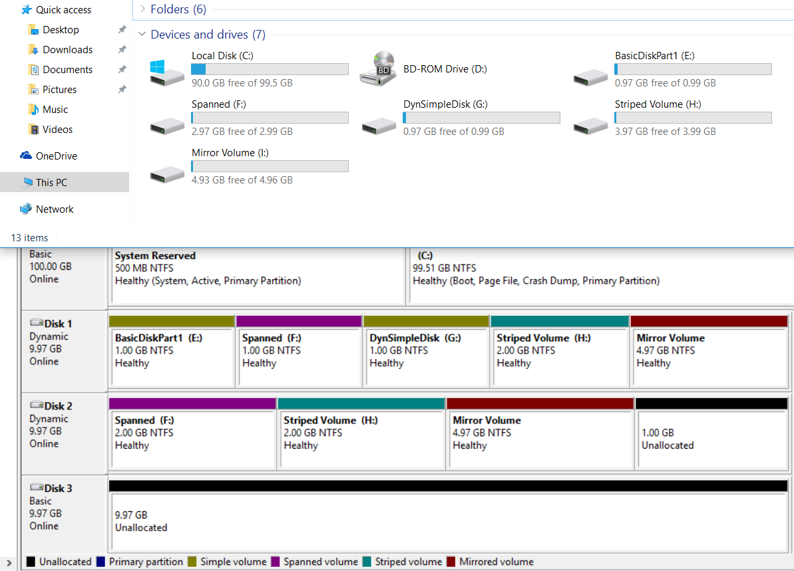

To clear all partitions and volumes from a disk

Clear-Disk <diskno> -RemoveData

create VHD and VHDX files with powershell

* New-VHD-path C:\VHD\MyDrive.vhdx -SizeBytes 60GB -Dynamic >> 60gb’lık sanal disk oluşturur
* Convert-VHD .\test.vhd .\test.vhdx
* Mount-VHD –Path c:\test\testvhdx.vhdx (-ReadOnly)
* Dismount-VHD –Path c:\test\testvhdx.
* Get-VHD –Path c:\test\testvhdx >> info about disk

Recommendation

VHD>fixed size

VHDX>dynamic size

NFS and SMB shares

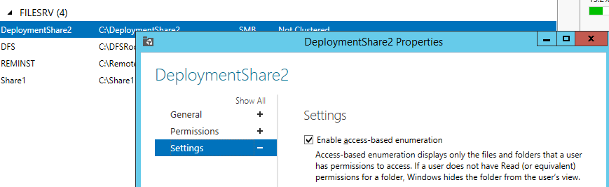

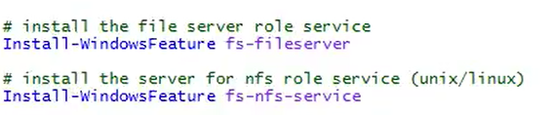

Creating and viewing share

New-SmbShare –Path <folderpath> -Name Data –FolderEnumerationMode Accessbased –FullAccess test.local\user1 -ChangeAccess test.local\user2 –ReadAccess test.local\user3

Get-SmbShare –Name Data

View access rights

Get-SmbShareAccess –Name Data

Add access right

Grant-SmbShareAccess –Name Data –AccessRight Full –Accountname test.local\user4 –Force

Remove access right

Revoke-SmbShareAccess –Name Data –AccessRight Full –Accountname test.local\user4 –Force

Block-unblock access

Block-SmbShareAccess –Name Data –AccessRight Full –Accountname test.local\user5 –Force

UnBlock-SmbShareAccess –Name Data –AccessRight Full –Accountname test.local\user5 –Force

Monitor sessions

Get-SmbSession

Close-SmbSession –ClientComputername <ip>

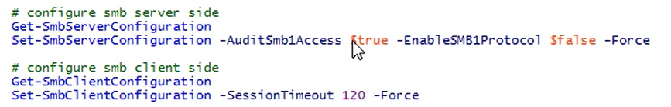

Other cmdlets















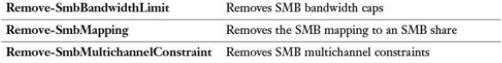

Server Storage

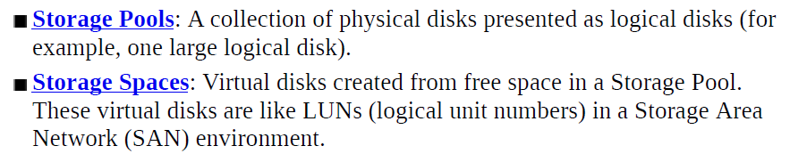

Storage Pool

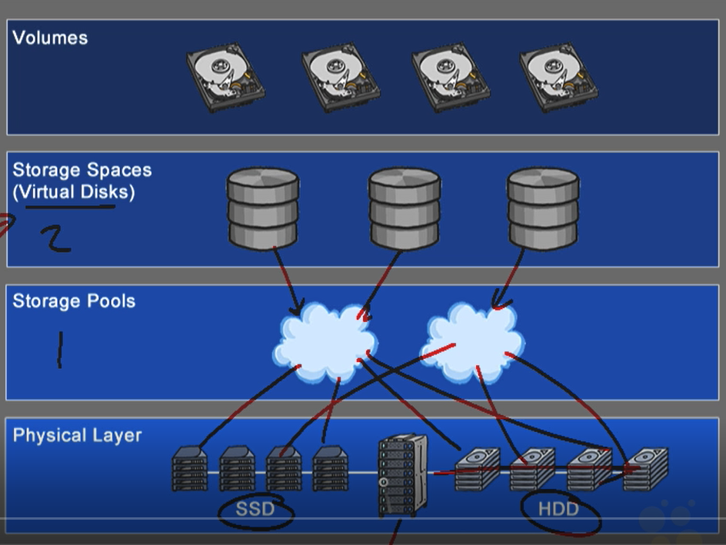

Simple>Raid0

Mirror>Raid1

Parity>Raid5

Tiering> SSD+HDD (data is dynamically moved based on frequency of access)

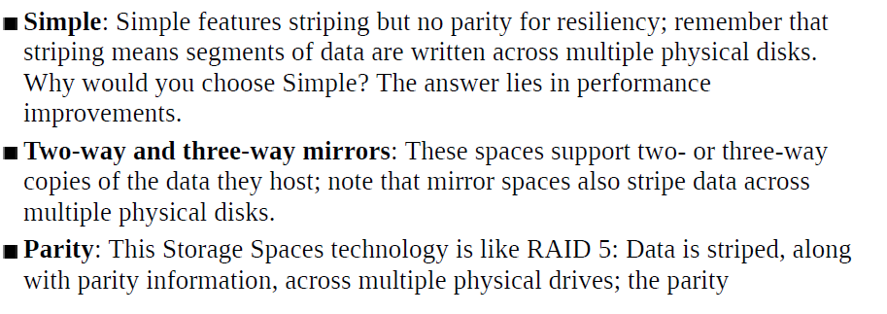

1. add disks

2. give storage pool name

3. associate disks with pool

Allocation>> automatic,manual,hot spare(keep disc idle In case of failure)

4.give virtual disk name (can configure storage tier)

5. storage layout (simple,mirror,parity)

6. provisioning type

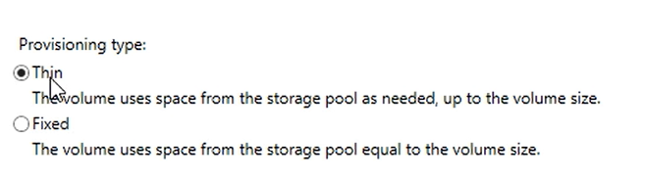

7. specify size

8. create volume from virtual disk

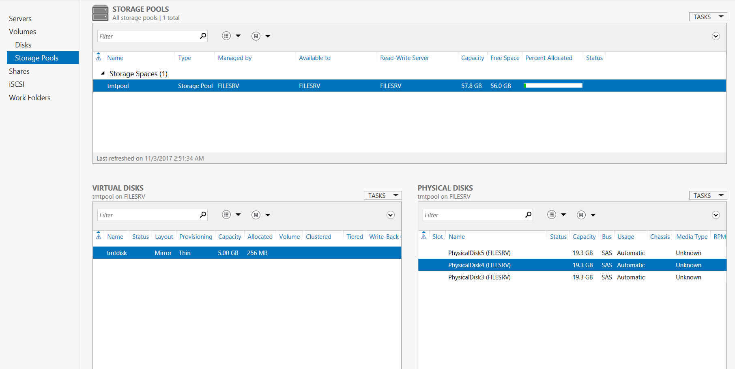

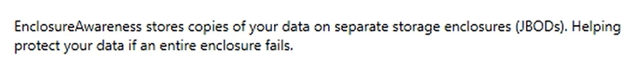

Removing storage pool

1. delete virtual disk

2. delete storage pool

3. reset disks

Show disks

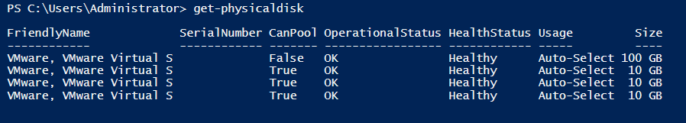

Physical disk removal

Parameters

**-StoragePoolFriendlyName**

**-StoragePoolName**

**-StoragePoolUniqueId**

**-VirtualDiskFriendlyName**

Set-Physicaldisk

Parameters

Usage:  **AutoSelect**, **HotSpare**, **Journal**, **ManualSelect**, **Retired**, and **Unknown**.

Media type: SSD, HDD

Reset-disk

PS C:\> $phydisk = (Get-Physicaldisk | Where-Object -FilterScript {$_.HealthStatus -Eq "Unhealthy"}

PS C:\> Reset-PhysicalDisk -FriendlyName $phydisk.FriendlyName

Creating storage pool from powershell

get-command *storagepool*

get-command *virtualdisk* >> "C:\Users\sccmadmin\Desktop\virtuakdiskcmdlets.txt"

get-storagepool

New-StoragePool -Friendlyname tmtpool -StorageSubSystemUniqueId (get-storagesubsystem).UniqueId -PhysicalDisks (Get-PhysicalDisk -CanPool $true)

New-VirtualDisk -FriendlyName tmtdisk -StoragePoolFriendlyName tmtpool -Size 5GB -ProvisioningType Thin -ResiliencySettingName mirror

Get-VirtualDiskSupportedSize -StoragePoolFriendlyName tmtpool

Initialize virtual disk



And create volume and partitions

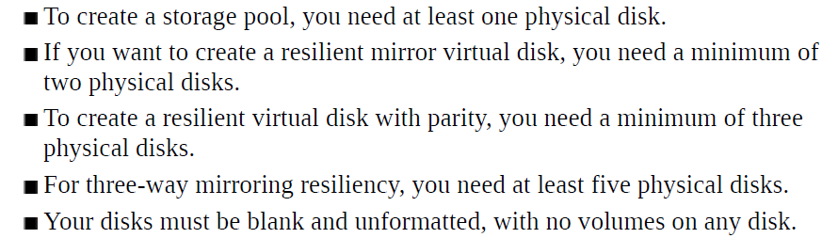

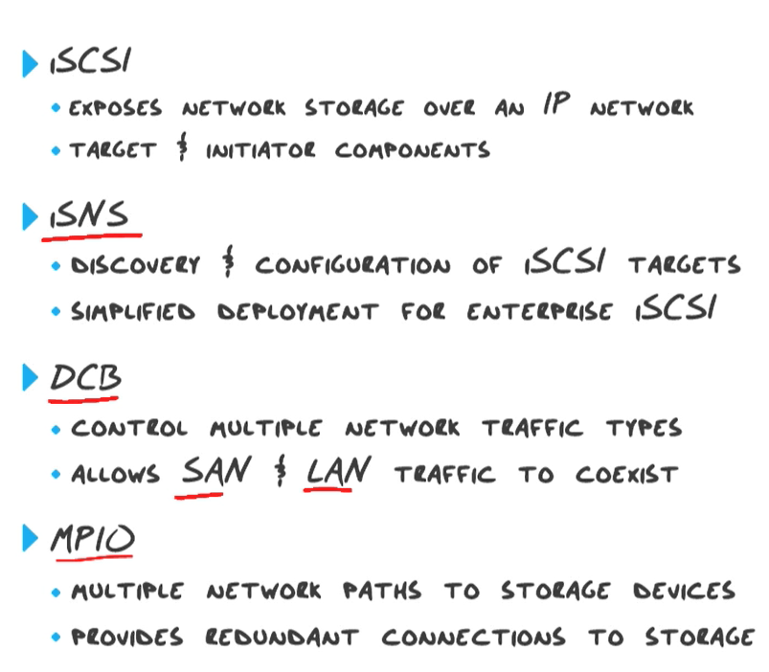

iSNS,DCB,MPIO >> feature’lar üzerinden kurulur

iSCSI target> add as a role

iSCSI initiator> enabled by defaut

>>hardware based allocation to specific traffic (lossless connectivity)

>>enables multiple TCP/IP connection from initiator to target

(resiliency)

for same iScsi session (multiple network cards on target and initiator

iSCSI target> to create virtual disk

on scsi target

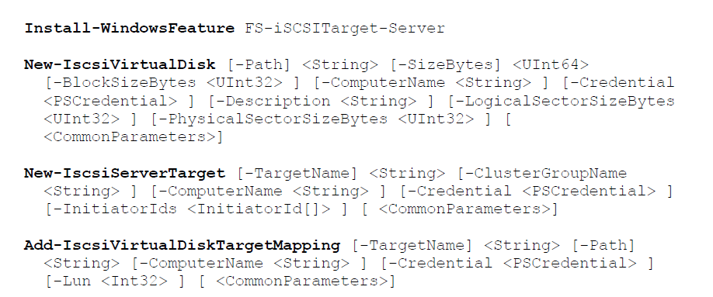

On scsi initiator

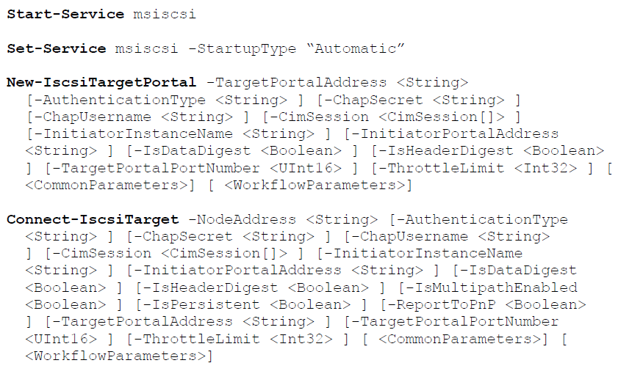

Start services related to iscsi



Start communication between iscsi target and initiator

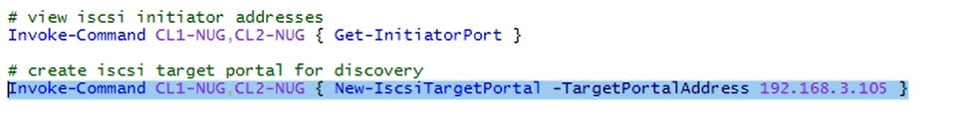

Client’lar target portal discovery yaptıgında targette gözükürler

Get-initiatorPort>> iscsi initiator’ların IQN lerini bulmayı sağlar

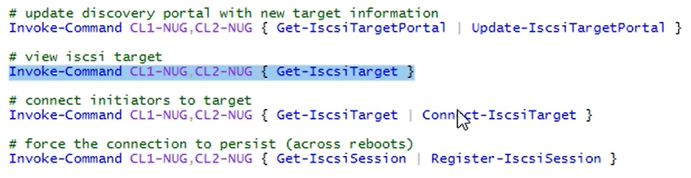

(normalde iscsi target ile initiator arasındaki ilişki persistent değil eğer target reoot ederse bağlantı kopar)

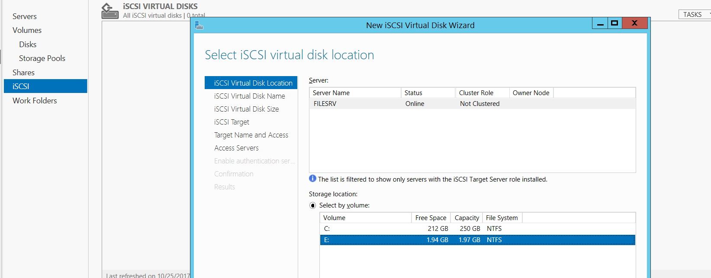

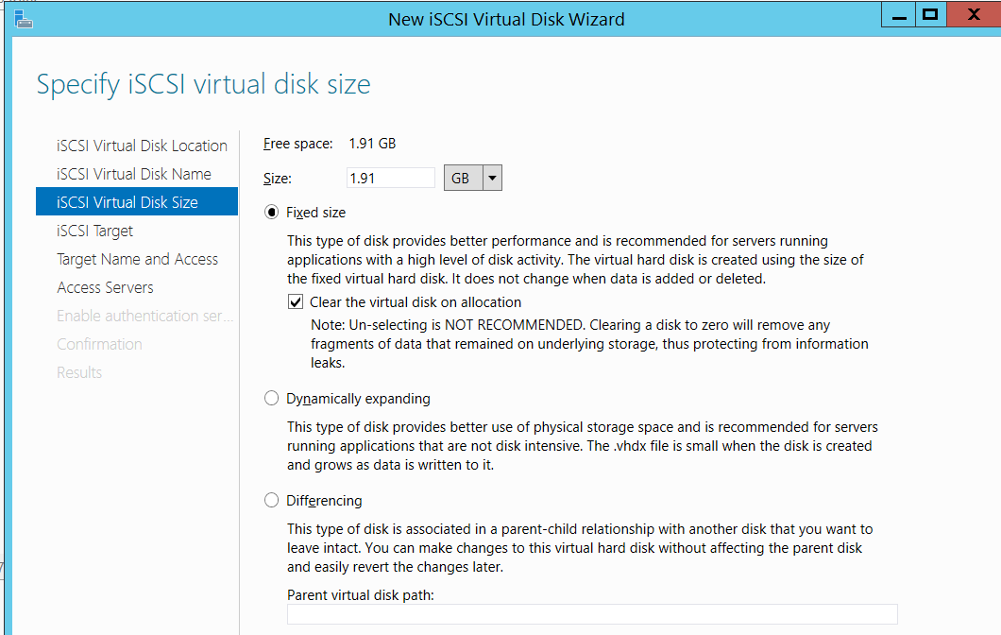

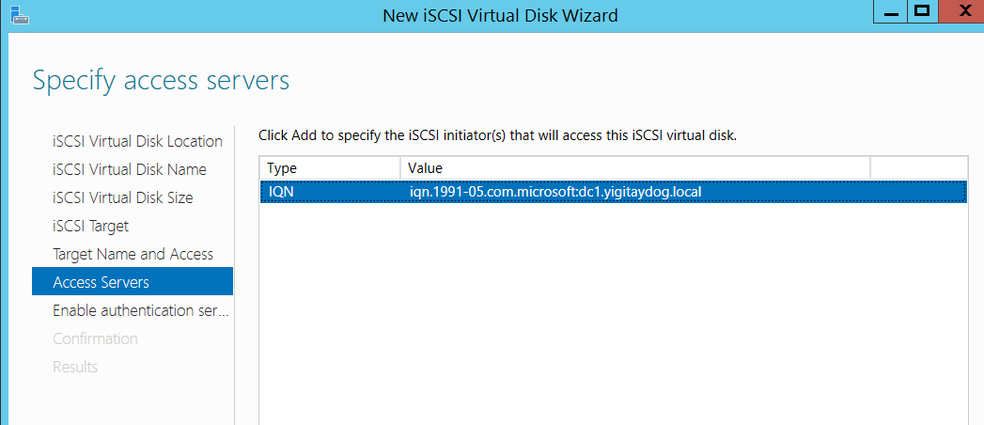

Storage Replica

*available for datacenter version of 2016

*gpt initialized disk needed

* for disaster recovry scenarios

*volume based block-level replication

Usage cases: Fileserver,sql server

* server to server, cluster to cluster, strech cluster

Server to Server reqs

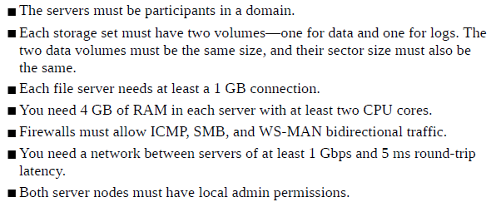









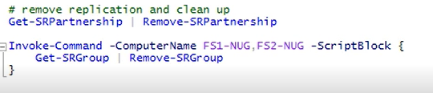

New-SRPartnership –Replication mode

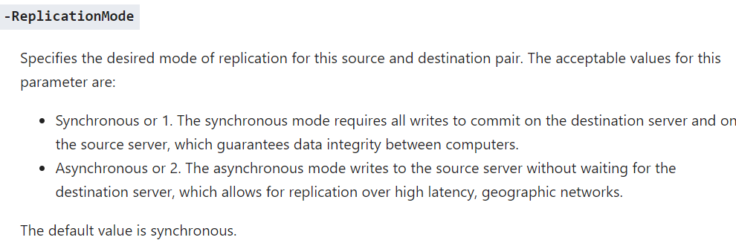

Data Deduplication

Periodic task, jobs run in background

Where to use> general purpose file servers,backup targets

DDPEval >> assesment for data dedup

Volume size up to 1GB, file size up to 1TB

Support for nanoserver

NTFS volumes needed

Install-WindowsFeature -Name FS-Data-Deduplication

Server Manager> File and Storage Services>Volume>Configure Deduplication

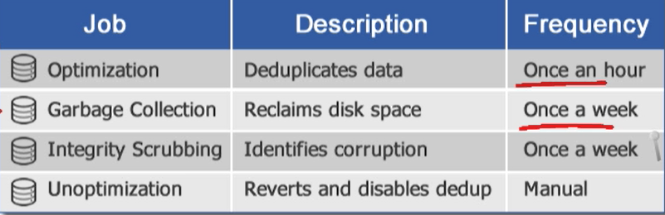

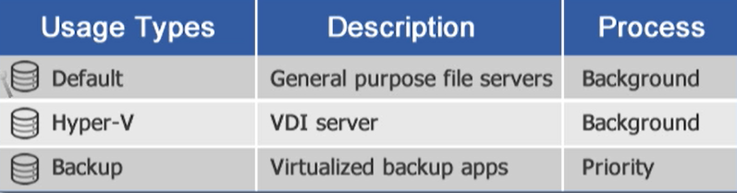

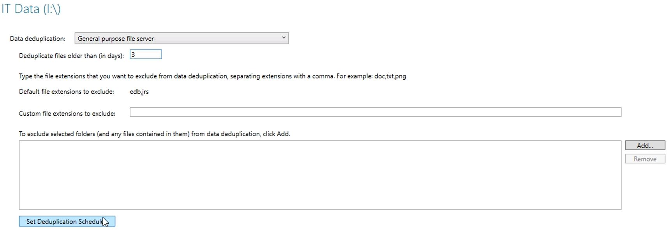

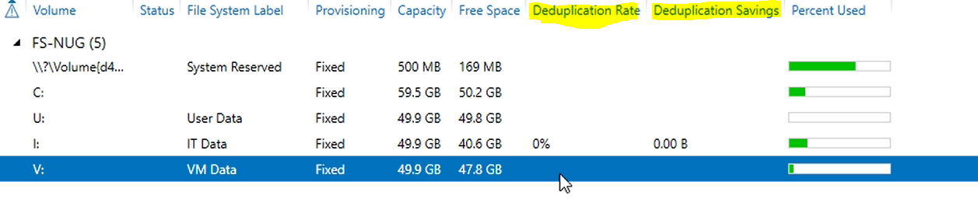

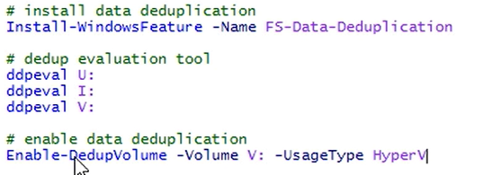

Ddpeval>> space savings

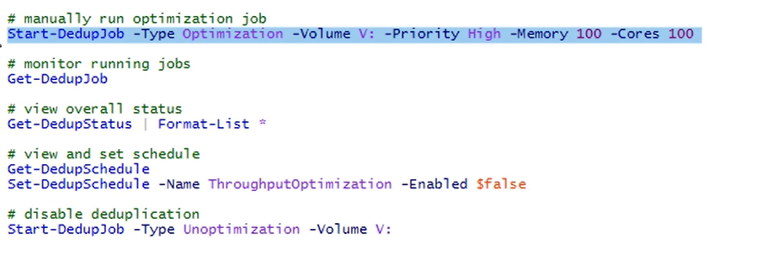

Eventviewer>applications and services logs>microsoft>Windows>Deduplication

Other cmdlets

**Expand-DedupFile** cmdlet expands an optimized file into its original location.

Expand-DedupFile -Path "D:\Share\File07.doc"

**Get-DedupJob** returns status and information for currently running or queued deduplication jobs.

Get-DedupJob -Volume "D:","F:"

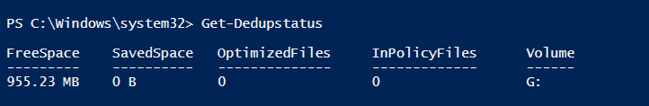

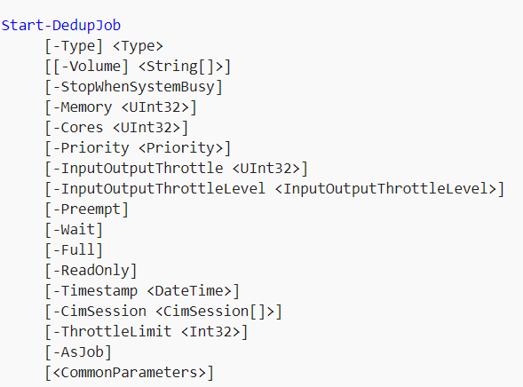

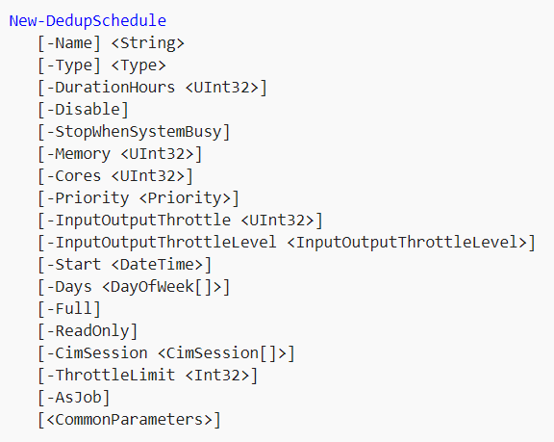

**Get-Dedupvolume**

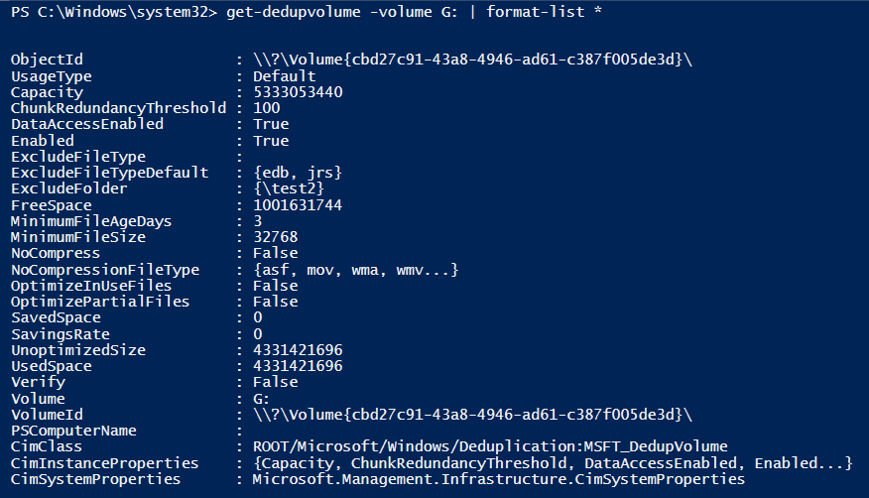

3günden önce yazılan dosyalar ve boyutu 32768 den fazla olan dosyalar deduplice olur

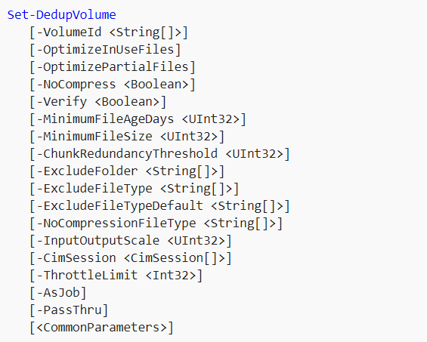

**CONTAINERS**

“Bir uygulama için ayrılmış izole alana verilen isimdir” Kendisine ayrılan bu alanda çalışırken sstemin geri kalanını ve diğer ugulamları etkilemeden işini yapar

İşletim sistemi seviyesinde sanallaştırma

Dedicate entire VM to application

Fast (does not load OS, OS is on host)

İsolated environments for apps and services

Install Feature> Containers

Container Hosts

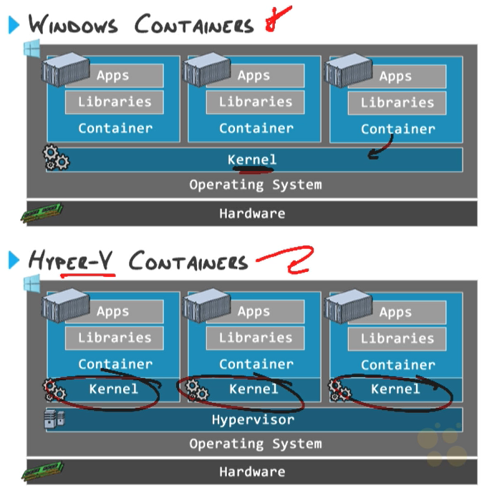

Repository

Container imajı ve bağımlılıklarını saklar

Preparing host

Install-WindowsFeature Containers

New-VMSwitch -Name *Virtual Switch Name* - SwitchType *Type*

New-NetNat -Name ContainerNat - InternalIPInterfaceAddressPrefix "172.16.0.0/12"

Get-VMNetworkAdapter -VMName *Container Host VM* | Set-VMNetworkAdapter -MacAddressSpoofing On

(for virtualized container host)

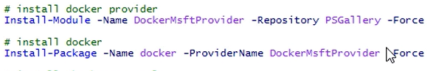

Docker version

Docker info

Docker search microsoft >>search images on docker hub

Docker pull microsoft/windowsservercore

Docker pull microsoft/nanoserver

Docker images > container imaj listesini görüntülemek

Docker run microsoft/windowsservercore ping –t localhost >> create background windows container

Docker run –it microsoft/windowsservercore powershell >> powershellden container yönetimini başlatır

Docker ps > currently runing containers

Docker ps –a > all containers

Docker stop (containerid) >>stops container

Docker commit (containerid) name-of-repository > create image from container

Docker inspect (containerid) >> view container settings

Docker rm (containerid) >>remove container

Install-WindowsFeatures Containers

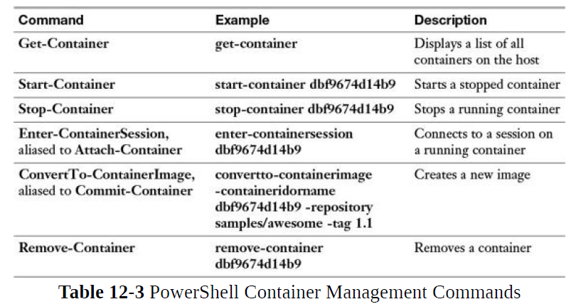



Request-ContainerImage –Repository microsoft/nanoserver

Get-ContainerImage

Get-Container

Stop-Container

Remove-Container

### #create windowscontainer with powershell

New-Container –name WindowsContainer –ImageIdorName microsoft/nanoserver –command powershell

Docker run microsoft/windowsservercore ping –t localhost

### **#create HyperVcontainer with powershell**

New-Container –name HyperVContainer –ImageIdorName –isolation HyperV –command powershell

Docker run –isolation=hyperv microsoft/nanoserver ping –t localhost



Remove-ContainerImage –ImageIdorName nuglab/nano –Force

Managing containers

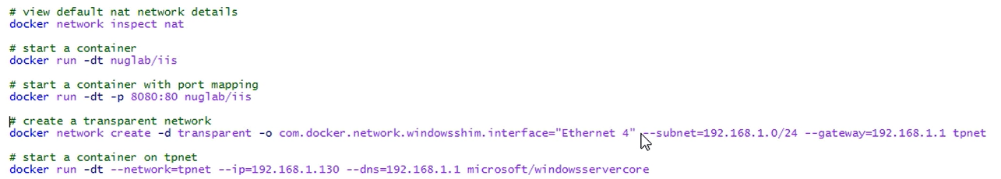

Docker volume create “volumename” >> create data volume

Docker run -–name “containername” –dt –v “volumename”:C:\data “nameofrepository” >> start containers using data volume

docker volume ls >> view data volumes

docker run – name “containername” –dt –v C:\temp:C\mount “nameofrepository” >> mount host directory

[Maintain and monitor server environments (10–15%)](https://www.microsoft.com/en-us/learning/exam-70-740.aspx#syllabus-6)

WSUS

* IIS üzerinden çalşan web tabanlı bir servistir
* Bits (background intelligent transfer service-dosya transfer süresince kullanılır) ve WinHTTP(windows sunucular ile http sunucular arası haberleşmeyi kolaylaştırır) bileşenlerine gereksinim duyar.
* Internet üzerinden güncellemeler TCP 80, TCP 443 portlarından gerçekleşir
* WSUS sunucularda Microsoft sql ürünü olmalıdır yada WID database
* İndirilen paketlerde güncelleme dosyası ve güncellemenin ne için olduğunu tutan meta veri parçası bulunur
* Her bilgisayara hangi yamaları kurduğumuzu raporlayabilir
* Güncellemeler sadece istenen bilgisayara uygulanabilir

Depolama yeri WSUS sunucunun yerel diski (kurulumda belirlenir, daha sonra değiştirilemez)

* Database’de sadece Windows kimlik denetimini desteklemektedir
* WSUS sunucuda static IP yapılandırılmalıdır

gereksinimler

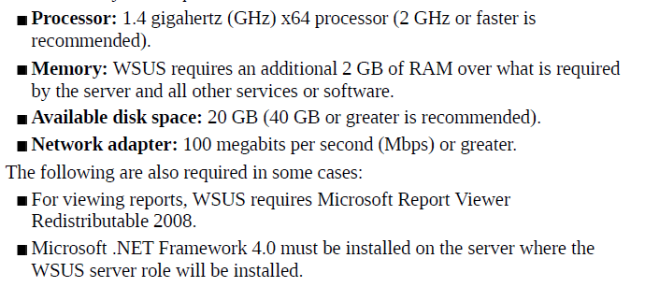

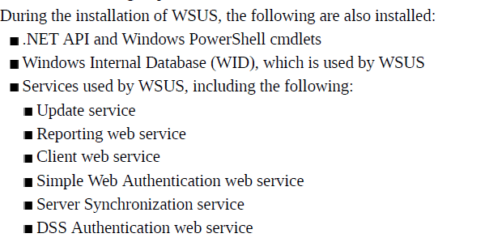

*büyük ağ yapıları ve şubeler varsa*

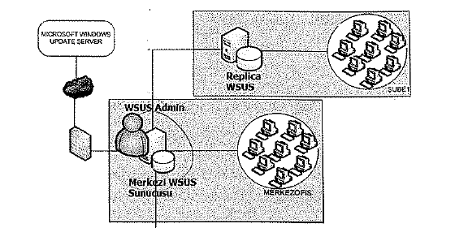

*Internete kapalı yapılar için*

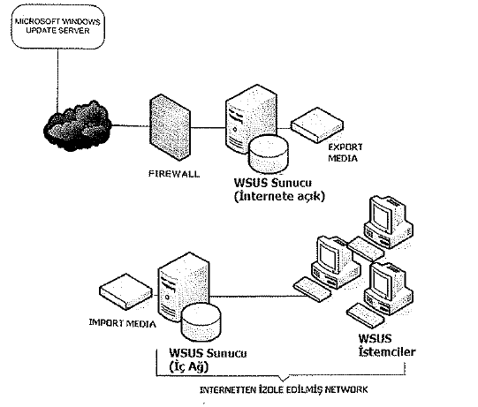

*İndirmelerin yapıldığı lokasyonlar*

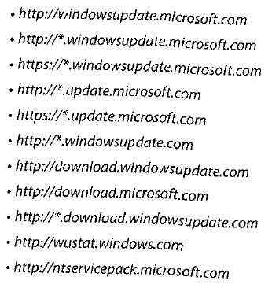

Update kategorileri:

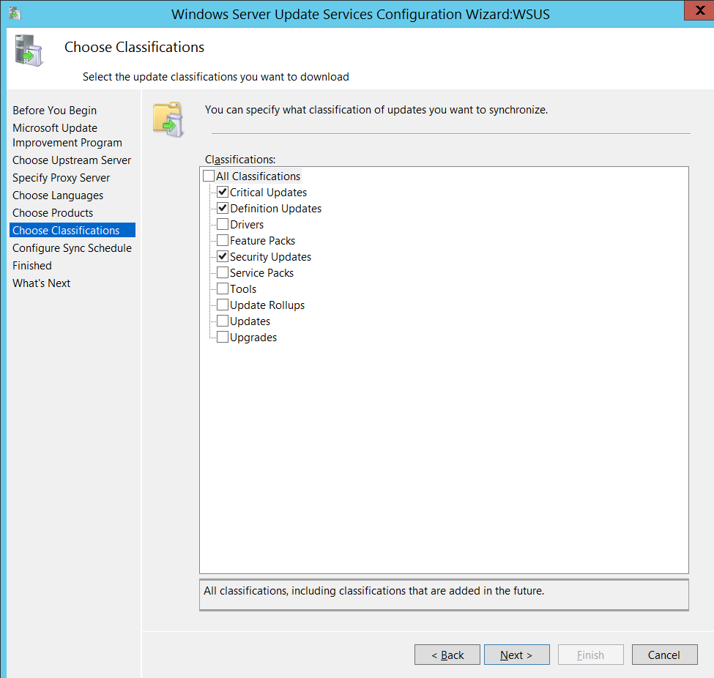

**GPO**

Computer Configuration- Administrative Templates-Windows Components-Windows Update

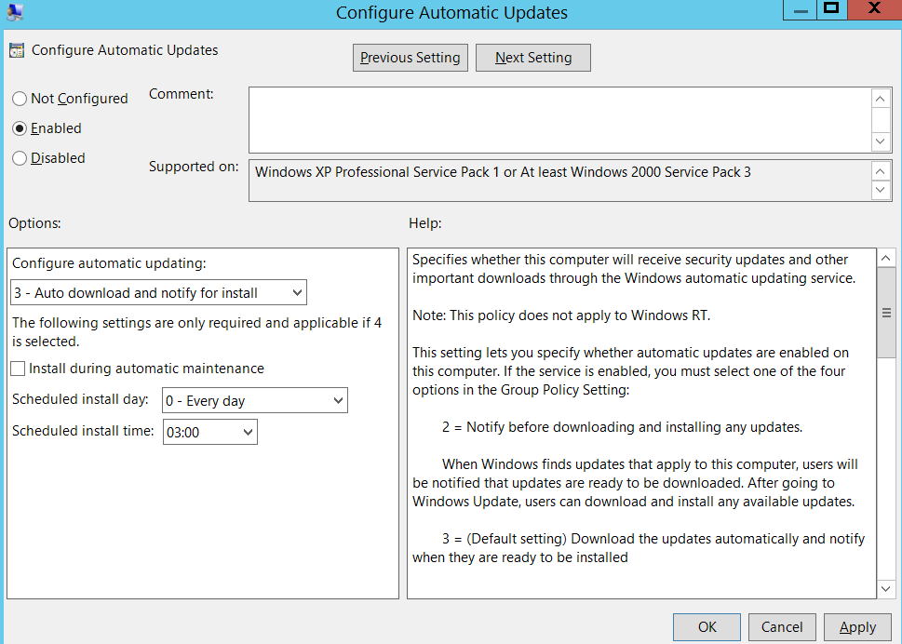

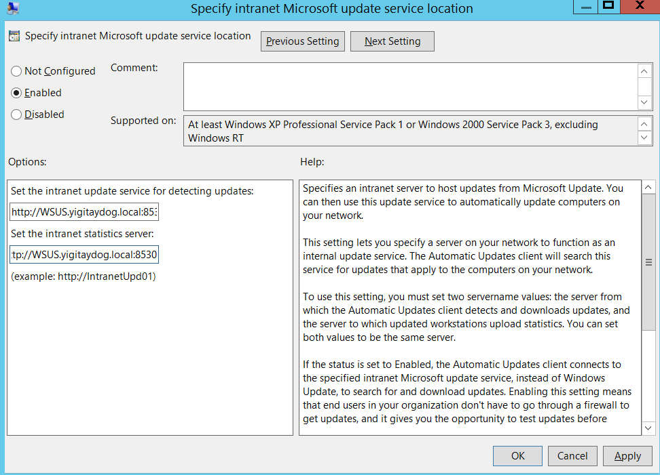

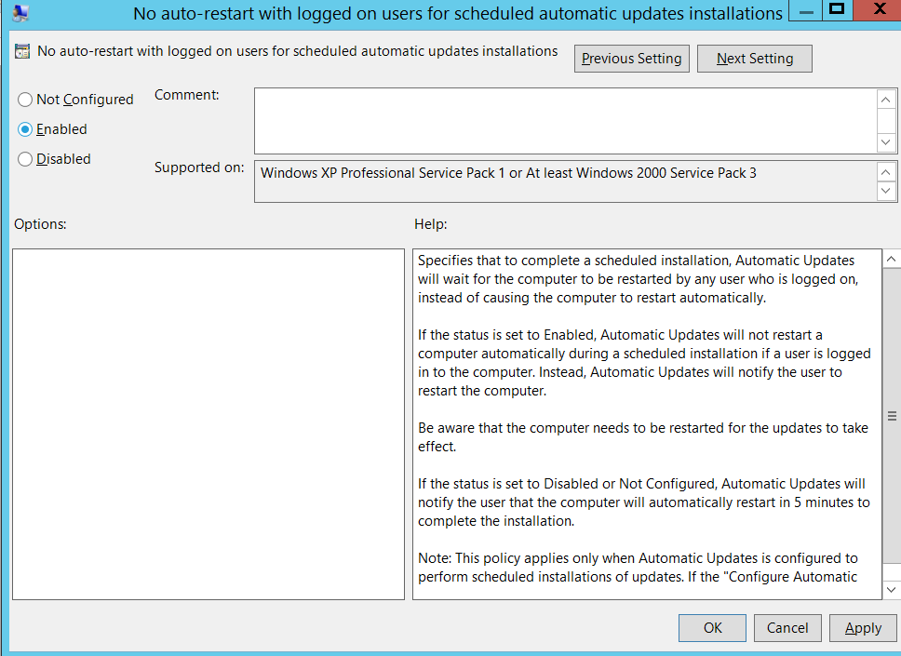

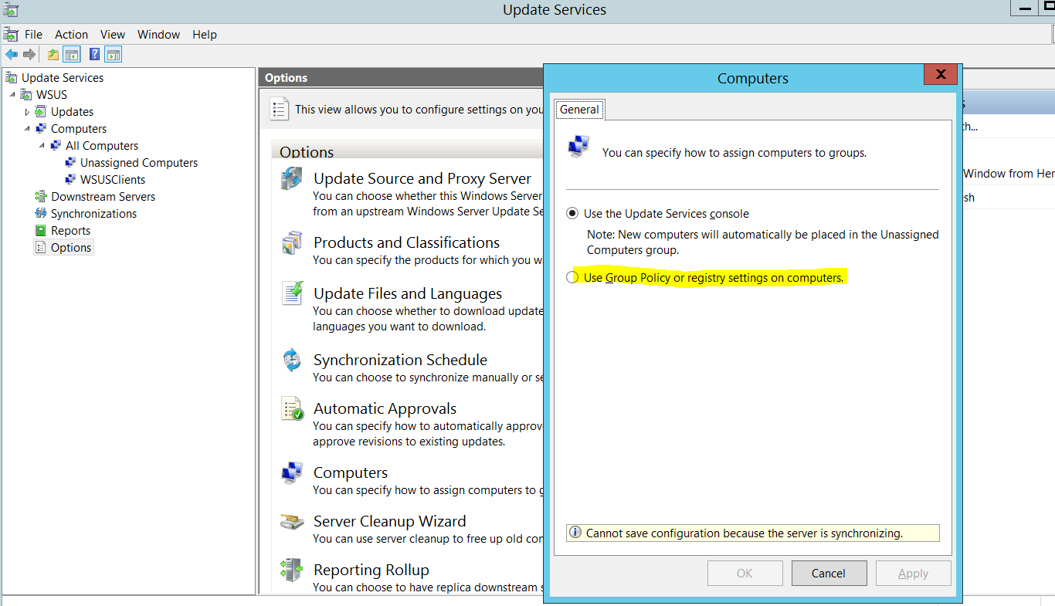

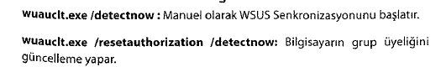

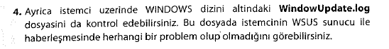

Client üzerinden status report çekebilmek için WSUS sunucuda

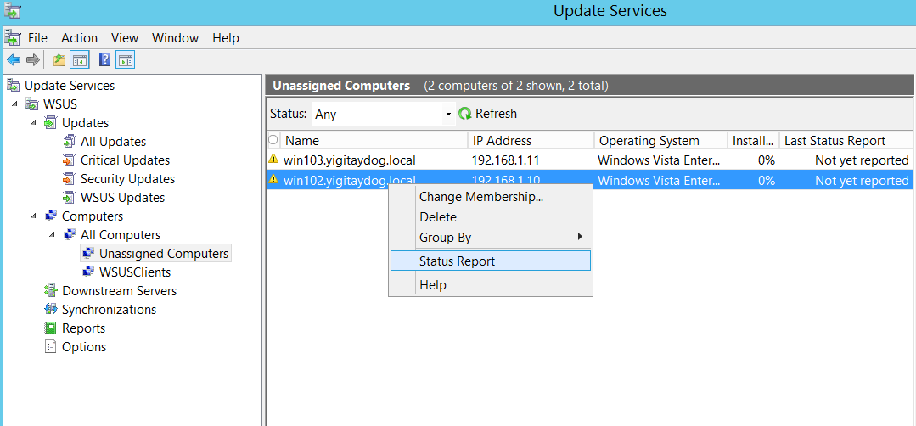

.net framework’de kurulmalıdır, kurulduktan sonra

Microsoft Report Viewer 2008 SP1 Redistributable yüklenmelidir

C:\WSUSFOLDER\WsusContents altına onaylanan updateler .cab olarak indirilir

Windows defender services

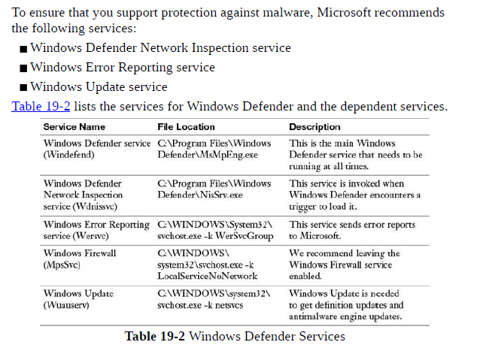

Back-up Strategy

Windows Server Backup writes its backup files in VHDX (virtual hard disk) format

Locations >> internal harddrive, network share, external hard drive, network share

Cmds

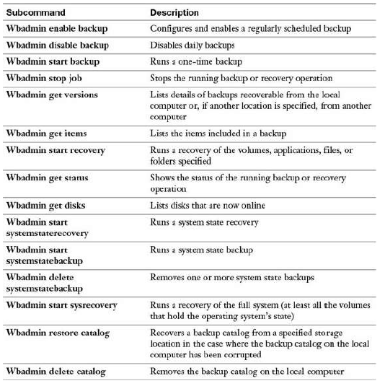

Bare metal recovery>> system components,system partition, win recovery environment

System state>>

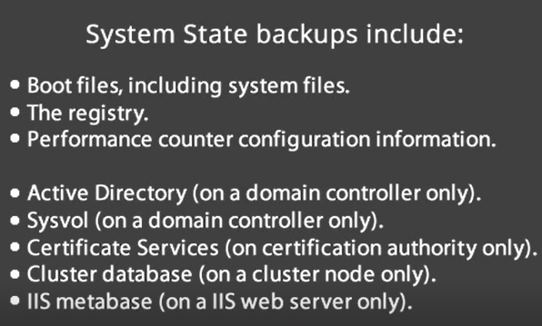

HyperV host+ guest backup

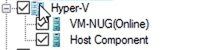

IIS>

System state backup da system32>inetsrv alınır

İnetpub>wwwroot

Domain Controller>

System State

FileServer>

Volumes

Monitoring

Task Manager>Resource Monitor(does not work on servercore)

Performance Monitor

Here are some examples of critical counters along with desired values for general server health:

**LogicalDisk - % Free Space**: Greater than 15%

**PhysicalDisk - % Idle Time**: Greater than 20%

**PhysicalDisk - Avg. Disk Sec/Read**: Less than 25 ms

**PhysicalDisk - Avg. Disk Sec/Write**: Less than 25 ms

**PhysicalDisk - Avg. Disk Queue Length**: Should not be larger than twice

the number of physical disks

**Memory - % Committed Bytes in Use**: Less than 80%

**Memory - Available Mbytes**: Greater than 5% of total RAM

**Processor - % Processor Time**: Less than 85%

**System - Processor Queue Length**: Should be more than twice the number

of CPUs

**Network Interface - Output Queue Length**: Less than 2



**HYPERV**

.vmcx> config settings

.vmrs>runtime data

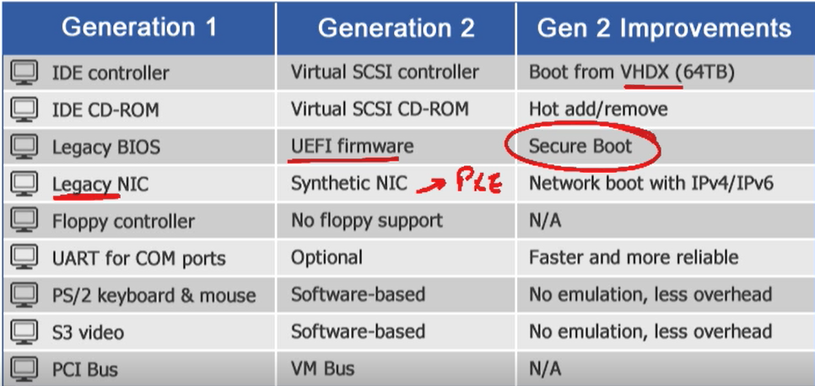

Gen2 doesnt support 32bit OS

Gen2 doesnt suppor FreeBSD

İt is possible to load OS from physical CD/DVD drive for gen1

Gen2> storage space direct,shielded VM,enhanced session mode

Server2016 Virtual machines doesn’t upgraded as soon as they moved to the upgraded host. (manually with powershell)

Requirements

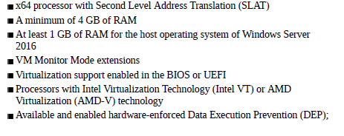

 A legacy network adapter also supports network-based installations because it includes the ability to boot to the Pre-Execution Environment (PXE boot).

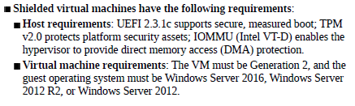

Shielded’lara bağlanamıyorsun

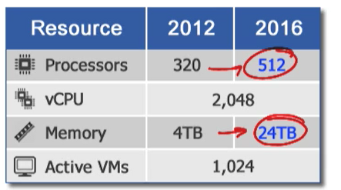

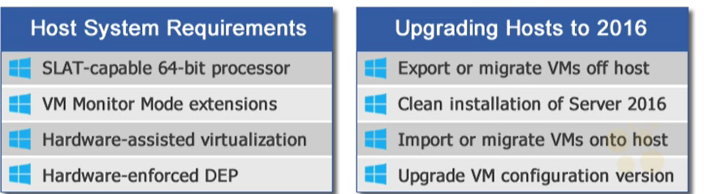

Requirement check> systeminfo ya da get-computerinfo

Delegation (to connect non domain hosts)

On host

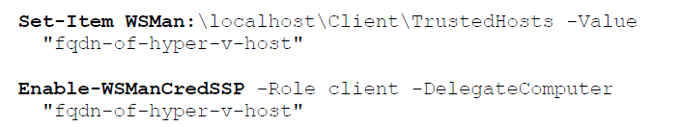

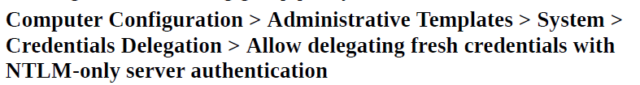

Enable

On nano

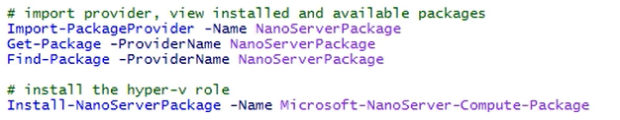

On win10



On desktop experience



Commands on host

#detailed propery about VM host

get-wmhost | format-list

#change location of disk and config file of new VMs

set-vmhost -VirtualHarddiskPath V:\VM -VirtualMachinePath V:\VM

#single use powershell direct session from host to VM

Invoke-Command -VMName testvm -Credential (Get-Credential) -ScriptBlock { }

#powershell direct session from host to VM

$session=New-PSSession -VMName testvm -Credential (Get-Credential)

Enter-PSSession -Session $session

copy-item -path c:\temp-host\test.txt -Destination c:\ -ToSession $session $#copying file from host to vm

Exit-PSSession

Remove-PSSession $session

start-VM -Name testvm

Restart-VM -Name testvm

**Set-VMProcessor**

Parameters

**-CompatibilityForMigrationEnabled**

Specifies whether the virtual processor's features are to be limited for compatibility when migrating the virtual machine to another host.

**-CompatibilityForOlderOperatingSystemsEnabled**

Specifies whether the virtual processor's features are to be limited for compatibility with older operating systems

**-EnableHostResourceProtection**

Specifies whether to enable host resource protection.

**-ExposeVirtualizationExtensions**

**-Maximum**

 maximum percentage of resources available to the virtual machine processor. Allowed values range from 0 to 100.

**-RelativeWeight**

Specifies the priority for allocating the physical computer's processing power to this virtual machine relative to others. Allowed values range from 1 to 10000.

**-Reserve**

Specifies the percentage of processor resources to be reserved for this virtual machine.

**Set-VMHost**

Parameters

**-EnableEnhancedSessionMode**

**-MaximumStorageMigrations**

**-NumaSpanningEnabled**

**-UseAnyNetworkForMigration**

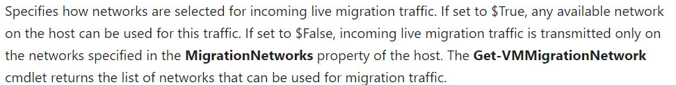

**-VirtualHardDiskPath**

**-VirtualMachineMigrationAuthenticationType (**Kerberos and CredSSP)

**-VirtualMachinePath**

Hyper-V administrators >> can connect and manages hyperV hosts

Nested virtualization requirements

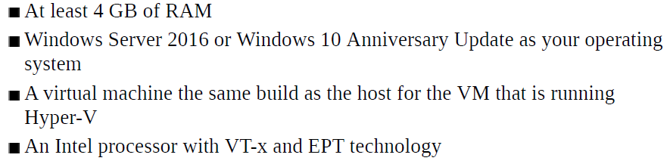

#nested virtualization enable on 1st VM

Set-VMProcessor -VMName -ExposeVirtualizationExtensions $true

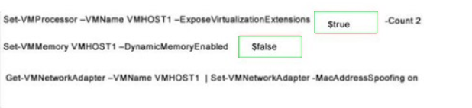

NO LIVE MIGRATIONS

**Set-vmnetworkadapter**

Parameters

**-AllowTeaming**

**-DhcpGuard**

**-MacAddressSpoofing**

**-MaximumBandwidth**

**-NotMonitoredInCluster**

#create and configure VM from host

new-VM -name testvm -memorystartupbytes 2GB -NewVHDPath C:\VM\testvmdisk1.vhdx -NewVHDSizeBytes 40GB -Generation 2

Add-VMScsiController -VMName testvm

Add-VMDvdDrive -VMName testvm -ControllerNumber 1 -ControllerLocation 0 -Path

New-VHD -Path C:\VM\testvmdisk2 -SizeBytes 100GB -Dynamic

Add-VMHardDiskDrive -VMName testvm -Path C:\VM\testvmdisk2.vhdx

Start-VM -Name testvm

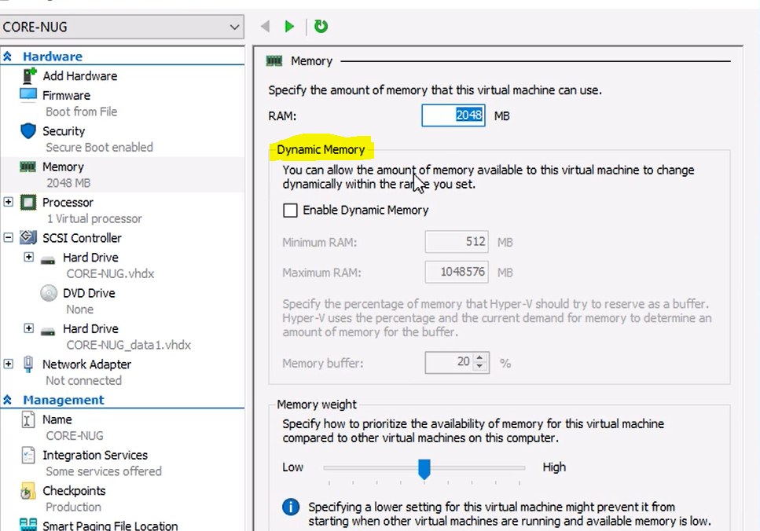

To add extra memory >>dynamic memory disabled, no need for shutdown just increase Ram

Server2016 and win10 and Linux(for adding)

Can be for gen1 and gen2

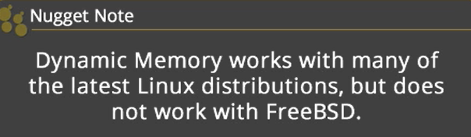

#configure dynamic memory

Set-VM -Name -MemoryStartupBytes 2GB -DynamicMemory -MemoryMinimumBytes 1GB -MemoryMaximumBytes 3GB

Set-VMMemory -VMName testvm -Buffer 10 -Priority 100

Numa nodes

#numa topology

Get-VMHostNumaNode

Set-VMHost -NumaSpanningEnabled $false

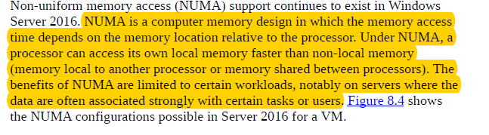

Smart paging

Apply to running machines> host ta yeterli ram olmadığı durumda makinelerin paging lokasyonundan restart edilebilmesini sağlar

smart paging, which eliminates the need to provide more memory than is needed to run the VM just because VM startup might temporarily require more memory.

Resource metering

#resource metering

Get-VM | Enable-VMresourceMetering

#view statistics

Get-VM | Measure-VM

New-VMResourcePool -Name memorypool -ResourcePoolType Memory

Stop-VM -name testvm -force

Set-VMMemory -ResourcePoolType Memory -VMName testvm

Measure-VMResourcePool -Name memorypool #memory statistics

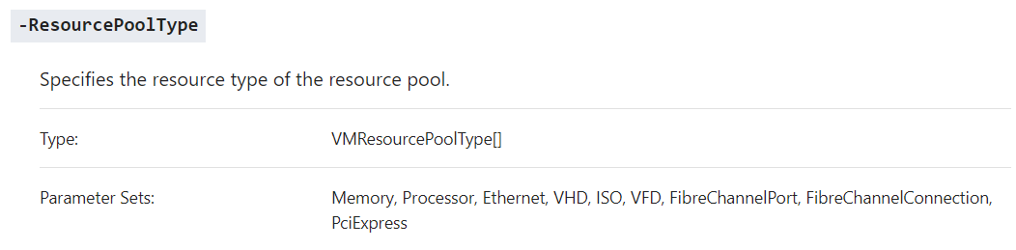

Add-VMNetworkAdapterAcl -VMName Redmond -RemoteIPAddress 10.0.0.0/8 -Direction Both -Action Allow

(apply to the traffic through a virtual machine network adapter)

**Create an ACL for Remote Desktop Protocol**

Add-VMNetworkAdapterExtendedAcl -VMName "TSQA01" -Action Allow -Direction Inbound -LocalPort "3389" -Protocol "TCP" -Weight 10 -Stateful $True

Enhanced session mode >display configuration, add local resources from host to VM

Enhanced Session Mode permits use of VMConnect to use a computer’s local resources within a VM.

RDP capabilities

No need for networking layer

Enabled on host level (VM settings)

Can toggle between basic session and enhanced session

Remote desktop session service must be running in background on VM

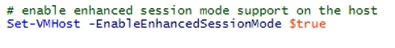

Secure Boot

Before you boot the virtual machine for the first time, you must configure it to use the Microsoft UEFI Certificate Authority.

Win and Linux



Direct Device Assignment

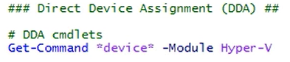

Deploying GPU to VM

Integration services

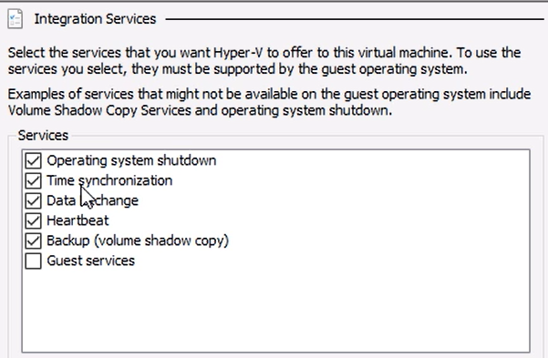

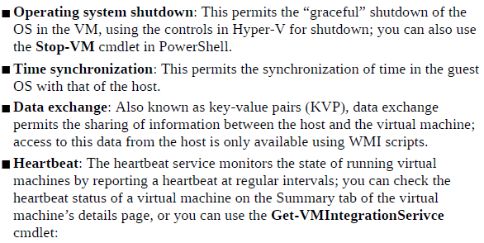

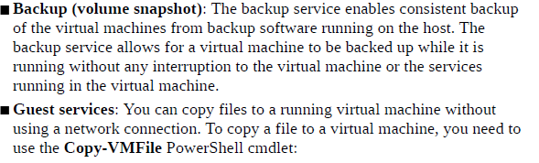

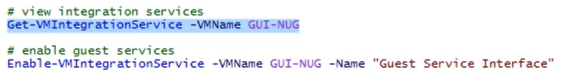

Import &Export VM

Export>harddisk, snapshot, config

Import>

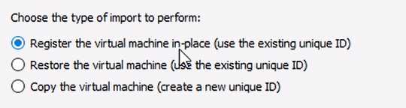

1>same location

2> new location for vm

#export VM

export-vm -name testvm -path \\filesrv\c$\vm\exports

#import VM

Import-VM -Path C:\VM\Exports\testvm

Upgrading VM version

Get-VM | update-VMVersion (2016hyperV>8.0)

QoS

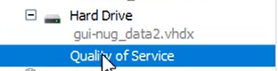

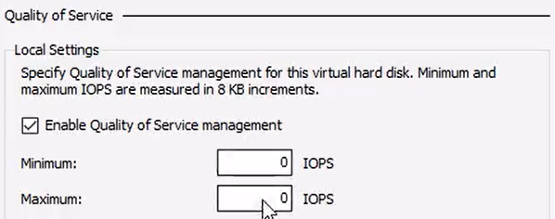

Shared Drive>> all VM that run same app share same disk

VHD Set (vhds,avhdx) or VHDX

**Pass Tru hard disk**>> host taki diskin vm tarafından kullanılması

A pass-through disk permits a virtual machine to access the actual hard disk of the host directly rather than using a virtual hard disk. For example, you might use a pass-through disk setup in order to have a virtual machine access an iSCSI LUN or a directly attached physical hard disk.

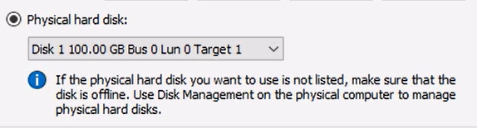

1. Take disk offline
2. Choose physical hard disk from scsi controller

#pass thru disk

Add-VMScsiController -VMName testvm

Add-VMHardDiskDrive -VMName testvm -DiskNumber 1 #from host disk

-ControllerType SCSI -Controllernumber 1 -ControllerLocation 0

**Differencing disk**>> base disk oluşturulur yeni makineler bu diski base alır



#create disk

new-VHD -Path C:\VM\testvmdiskk.vhdx -SizeBytes 50GB -Dynamic

#attach disk

Add-VMHardDiskDrive -VMName testvm -Path C:\VM\testvmdiskk.vhdx -ControllerType SCSI -ControllerNumber 0 -ControllerLocation 2

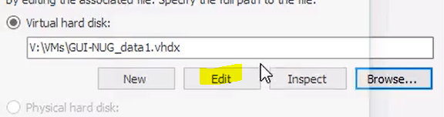

Edit disk

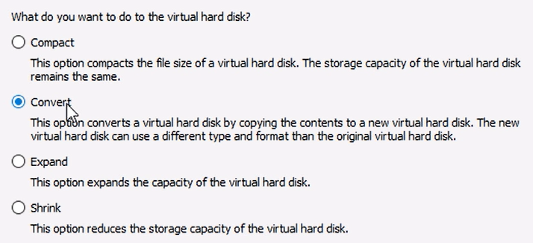

(expand and shrink when vm is on)

Production Checkpoint>>data consistent (for time sensitive apps like exchange, AD, SQL)

#compact vhdx (reduce disk space of dynamically expanding VM)

Optimize-VHD -Path C:\VM\testvmdiskk.vhdx

Resize-VHD -Path C:\VM\testvmdiskk.vhdx -SizeBytes 10GB

#modify vhd

Convert-VHD -Path C:\VM\testvmdiskk.vhdx -DestinationPath C:\VM\testvmdiskk2.vhdx -VHDType Fixed –DeleteSource

Checkpoint notes

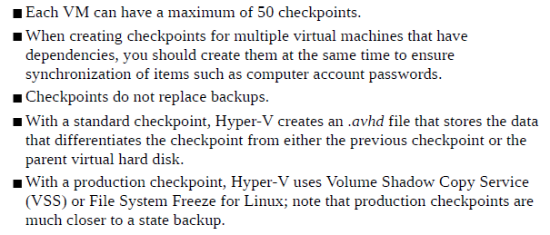

#create base checkpoint

Set-VM -Name testvm -CheckPointType Production

Start-VM -VMName testvm

Checkpoint-VM -Name testvm -Snapshotname snap1

Get-VMSnapshot -VMName testvm

....

Restore-VMSnapshot -VMName testvm -Name snap1

Get-VMSnapShot -VMName testvm | Remove-VMSnapShot

New-VMSwitch -Switchname Vinternal -Switchtype Internal

Add-VMNetworkAdapter -VMName testvm -Switchname Vinternal

**External**>> VM communicate with eachother, host and host’s network

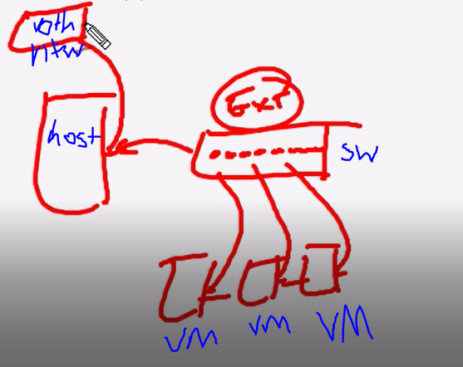

**Internal>>**VM communicate with eachother and host

Private>> only VM can communicate with eachother

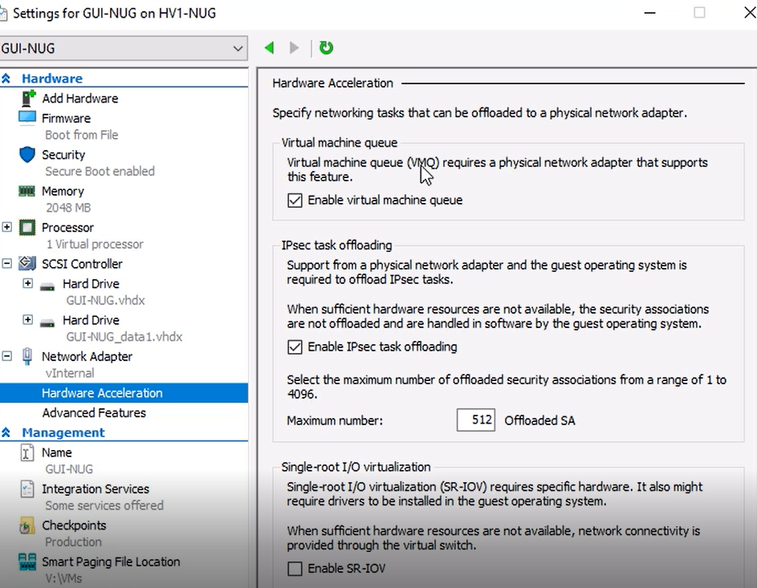

VMQ> store incoming packets on physical NIC and deliver directly to VM (bypass virtual switch)

hardware packet filtering that delivers packets from an outside virtual machine network directly to a virtualized host operating system.

IPsec task offloading> to reduce the load on CPU

SRIOV> permits compatible network adapters that connect via PCI Express to bypass the Hyper-V virtual switch completely and be mapped directly to a VM. This, of course, gives very low-latency connectivity.

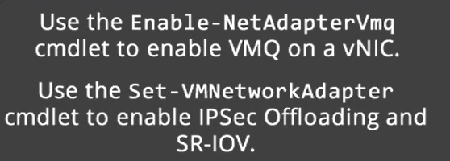

NICTeaming> load balancing, fault tolerance

TeamingMode

Switch independent> switch does not know NIC teaming, no load balancing offer

Switch dependent> switch know NIC teaming, load balancing offer

LoadbalancingMOde

AddressHash> which nic traffic should be sent

Hyperv> host and many VM

(2016) dynamic> combination

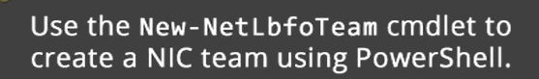

NIC teaming on VM settings



SET-switch embedded teaming> alternative to nic teaming on host



Best practice offers

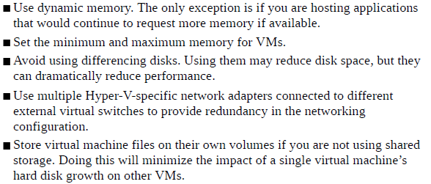

**HYPERV REPLICA**

Copy one VM from one host to another host

Minimize downtime

In domain environment

(On both host)

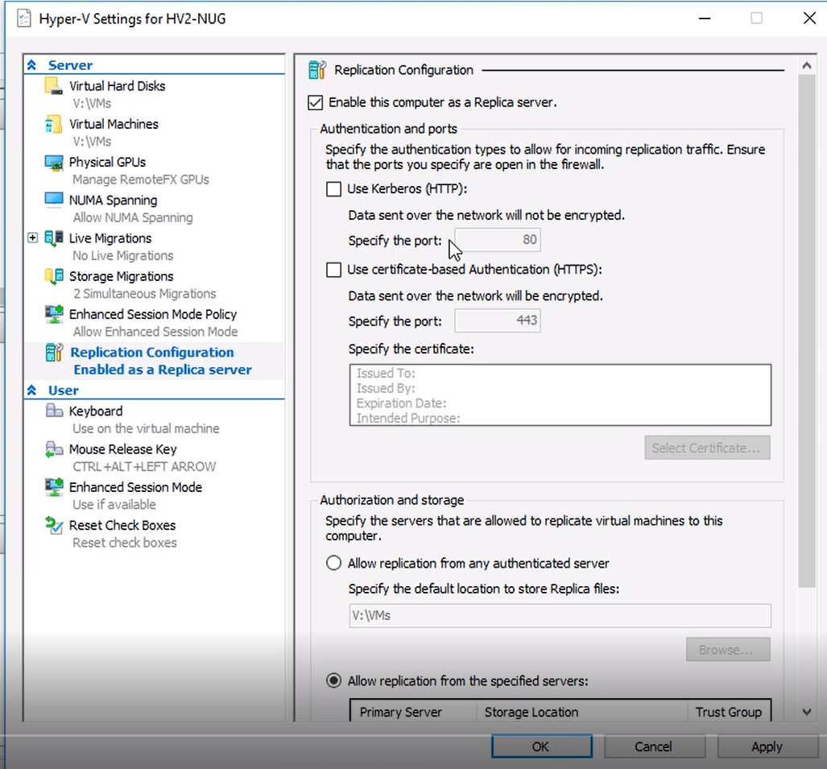

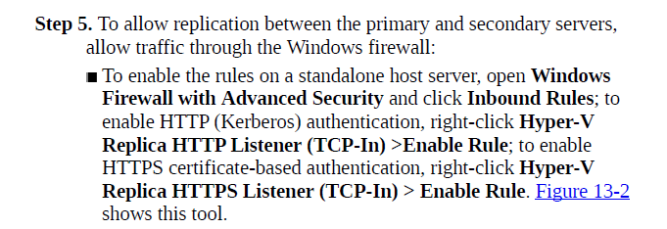

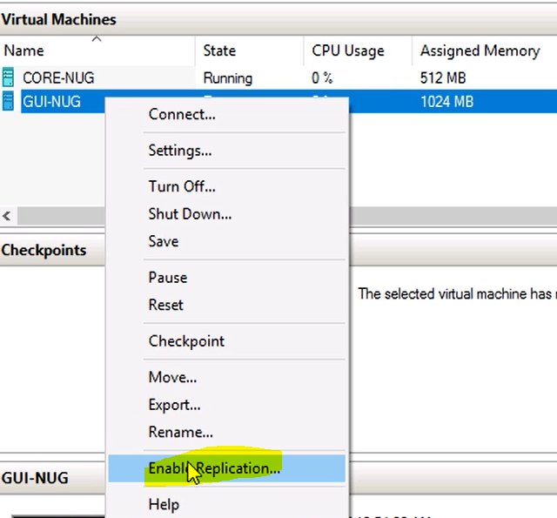

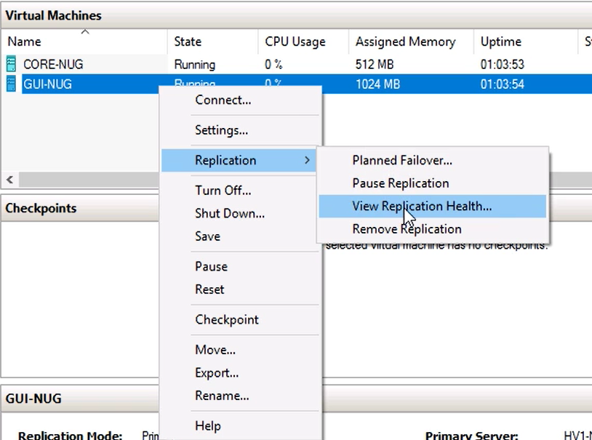

Replikasyon işlemi tamamlandıktan sonra

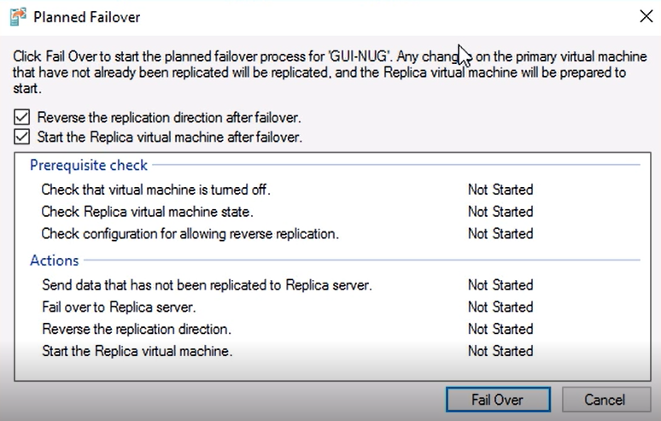

Yapılarak makine tamamen karşı tarafa taşınabilir

**LIVE MIGRATION**

**Reqs**

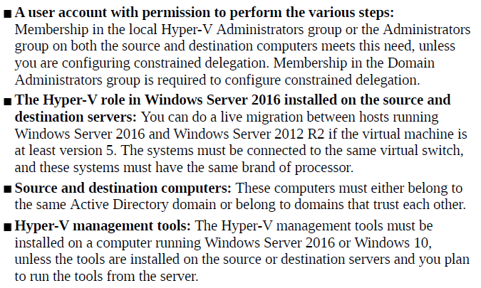

No service interruption

Live migration>> migrate just vm not storage, require shared storage, fastest

Shared nothing live migration>> not require shared storage, copy state of vm and local storage

Storage migration>> just migrate storage

(Enable live migration on boh host)

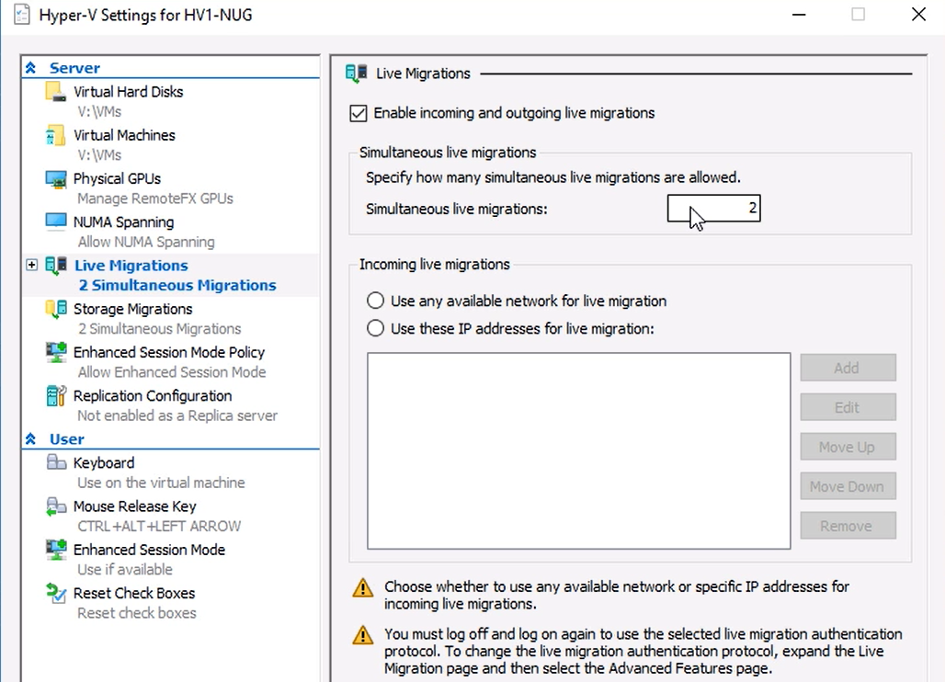

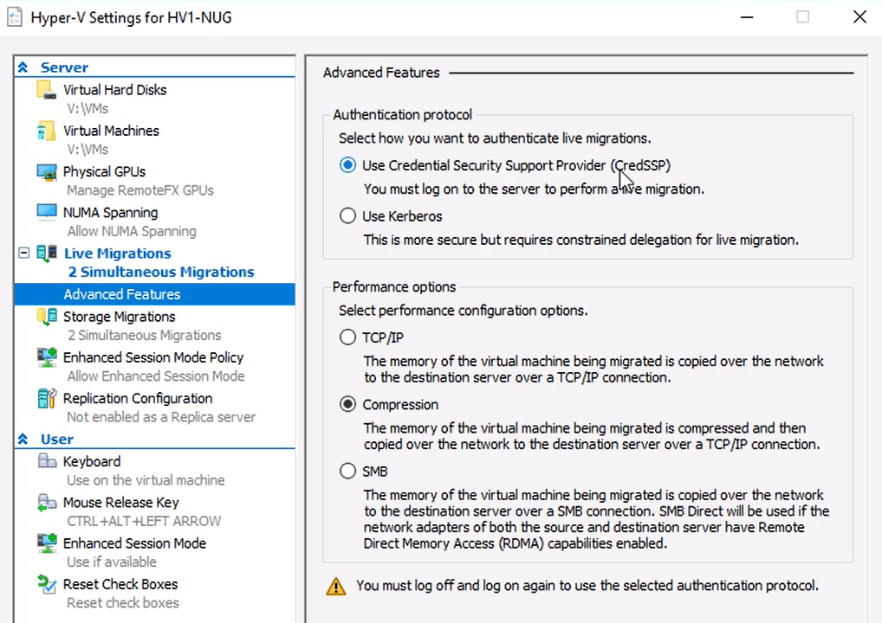

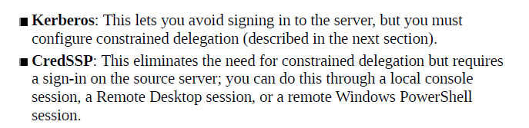

**TCP/IP**: Copies the memory of the virtual machine to the destination server over a TCP/IP connection

**Compression**: Compresses the memory content of the virtual machine before copying it to the destination server over a TCP/IP connection; this is the default setting

Use kerberos

Set up constraint delegation (cifs and microsoft virtual system migration service)

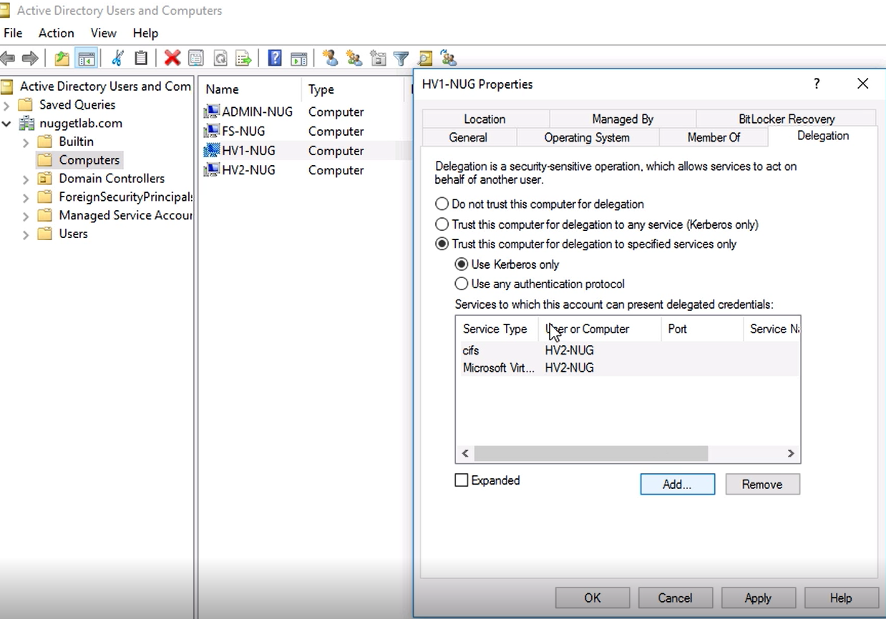

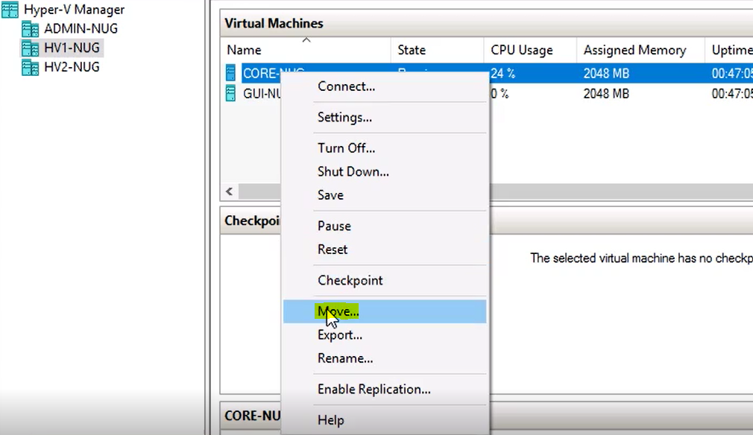

Bu işlem bitince VM tamamen karşı hosta taşınır

Wizard

1.choose move type (move the virtual machine or move virtual machine storage)

2.specify destination (machine name)

3.move VM data to single location ; move VM data by selecting where to move items; move only the virtual machine

4. move VM data automatically ; move VM hard disk to different locations ; move VM items to different locations

Shared nothing live migration

1.choose move type (move the virtual machine

2.specify destination (machine name)

3.move VM data to single location

4. move VM data automatically

Storage migration

1.move virtual machine storage

2.specify destination (machine name)

3.move VM data to single location

Live migration

1.move the virtual machine

2. specify destination (machine name)

3.move only the virtual machine

**FAILOVER CLUSTERING**

**Supports**

64 servers

1024 virtual machines per node

Requirements

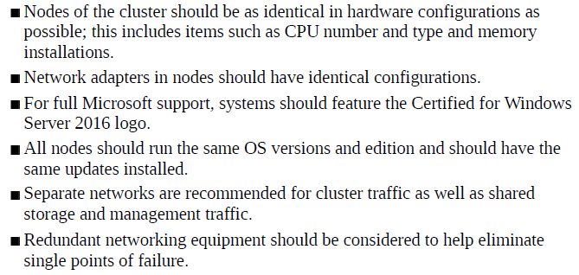

Same role or application on more than one server for high availability

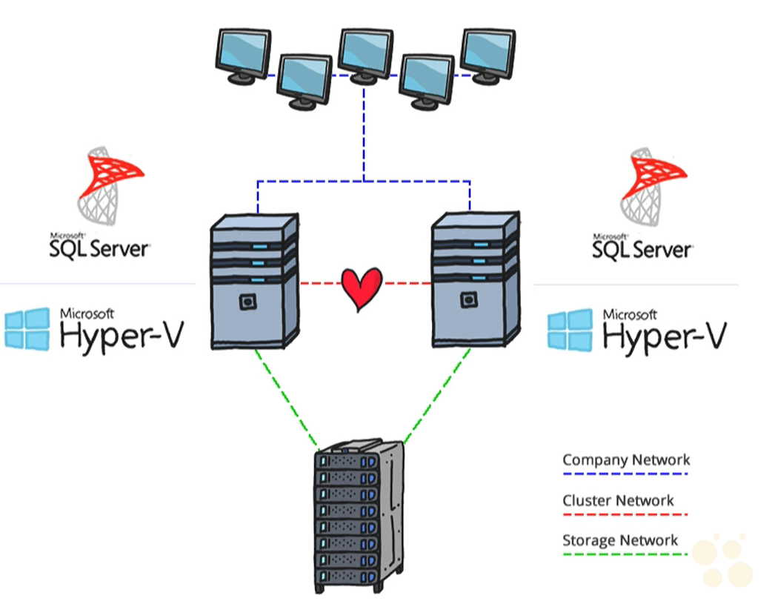

Storage network: (iSCSI) traffic

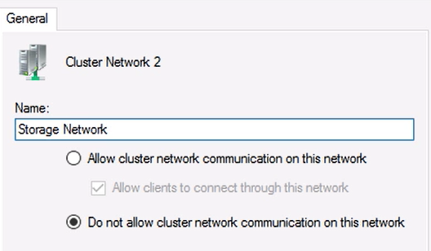

Cluster network: network without default gateway

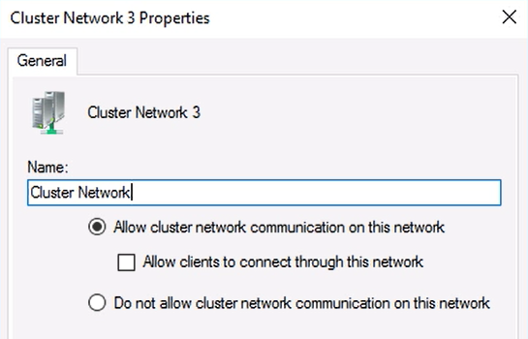

Company network:

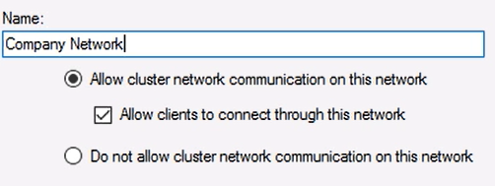

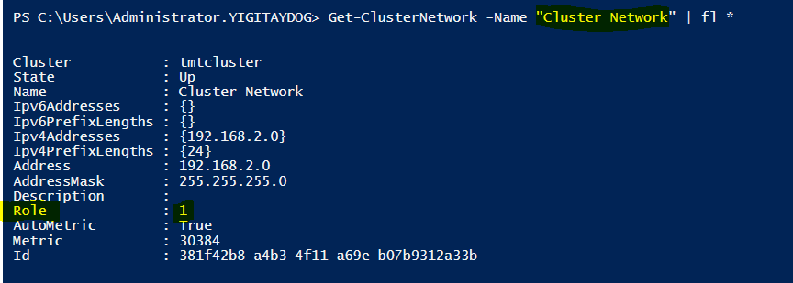

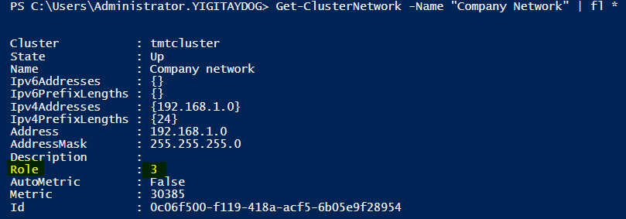

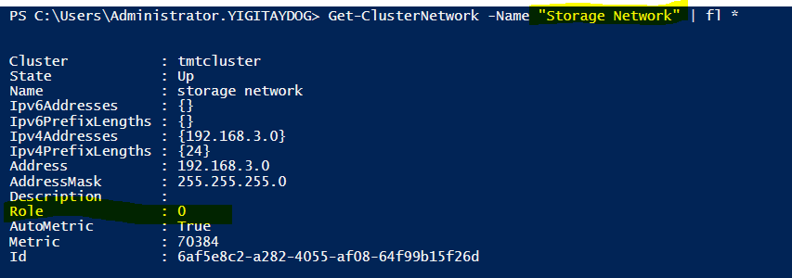

MPIO on storage (can be file with server with scsi target installed)

NIC Teaming on Clusters

Server 2012>> single domain cluster

Server 2016>> single domain cluster+multi domain clusters,workgroup clusters

Quorum

Number of failures that a cluster can cope before shutting itself down

Every node incluster has vote

Cluster maintains if voting is up 50 percent

Witness for vote>> disk, file share witness,cloud witness

Dynamic quorum> if nodes leaves cluster it takes vote with it

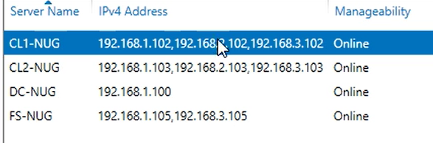

1network> company network

2>cluster network

3>storage network

CL1 ve CL2 de iscsi servisi calismalidir

FS de target disk(1virtual disk,1quorum)oluşturulup CL1 ve CL2 initiator olarak seçilir bağlantı sağlanır ve disklerden CL1 ve CL2 üzerinde volume oluşturulur

Get-IscsiTargetportal |Update-IscsiTargetPortal

Get-IscsiTarget | Connect-IscsiTarget

Get-IscsiSession | Register-IscsiSession

Install-WindowsFeature failover-clustering

İnstall fail over cluster feature on nodes (CL1,CL2)



#cluser aware updating

Install-WindowsFeature rsat-clustering –IncludeAllSubFeature

Validate cluster

Test-Cluster -Node node1, node2 -Ignore Inventory –Include "List System Drivers", "List Unsigned Drivers"

(validation tests for failover cluster hardware and settings. Tests can be run both before and after a cluster is set up)

Create cluster





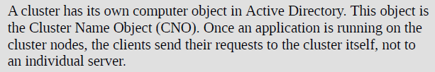

(multi-domain cluster)

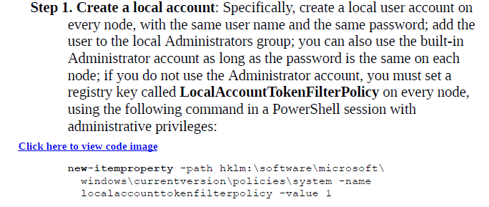

Step2. Add dns suffixes

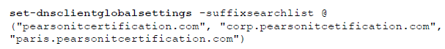

Step3



Configure quorum

There can only be one witness in a cluster.

each node in cluster has a vote

all nodes continually monitors votes

%50 of votes +1 ‘dan düşük olursa, node’lar kendini cluster’dan çeker

3types of witnesses

DisK: contains copy of cluster DB (single site) >> all node access to same shared storage

File Share: SMB file share containing witness.log file (multiple site)

Cloud witness: blob in cloud

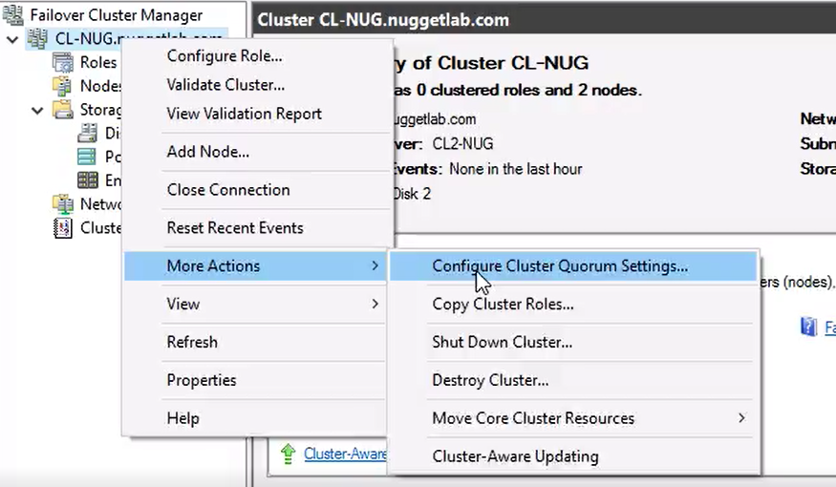

Cluser ismi AD users and computers ve dns record’larında oluşur

Set-ClusterQuorum>> change quorum type, add / change witnesses

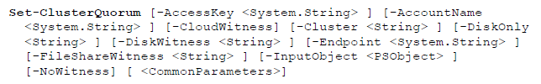

Cluster-aware updating (CAU)>> Windows Update coordination between nodes

Process

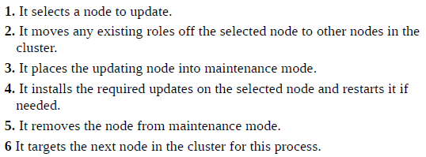

Operating Modes

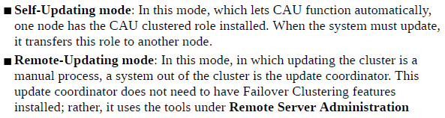

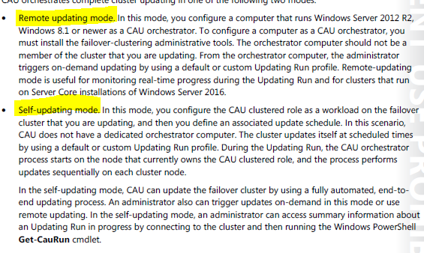

Bu işlem sonrası AD de



Hesabı oluşur

Check if cluster supports CAU



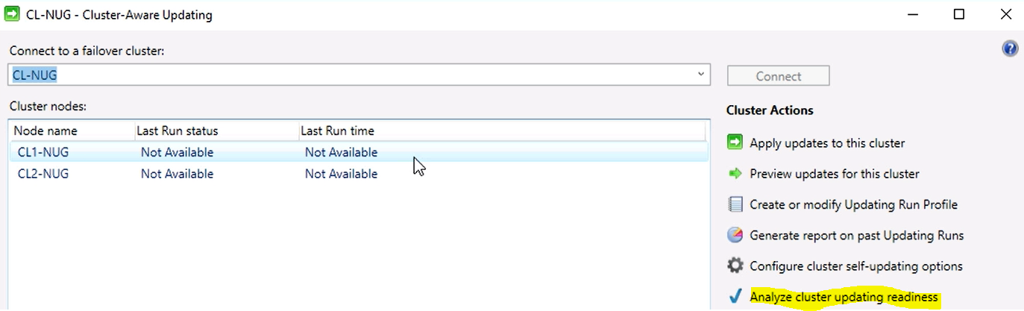

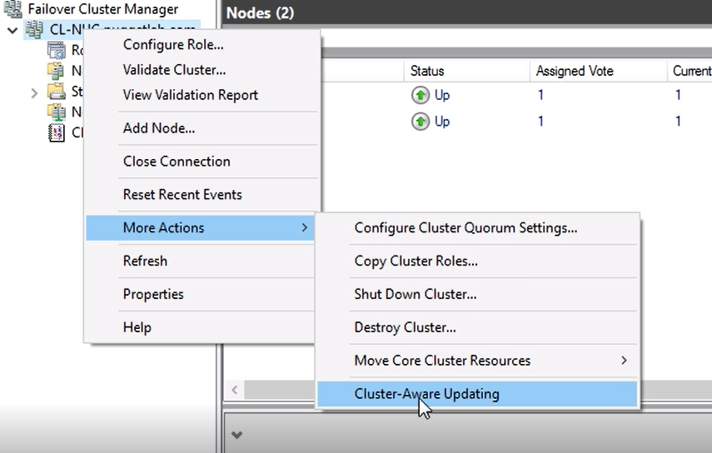

CL1 ve CL2 üzerine kurulacak

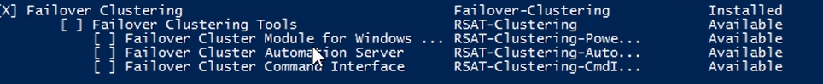



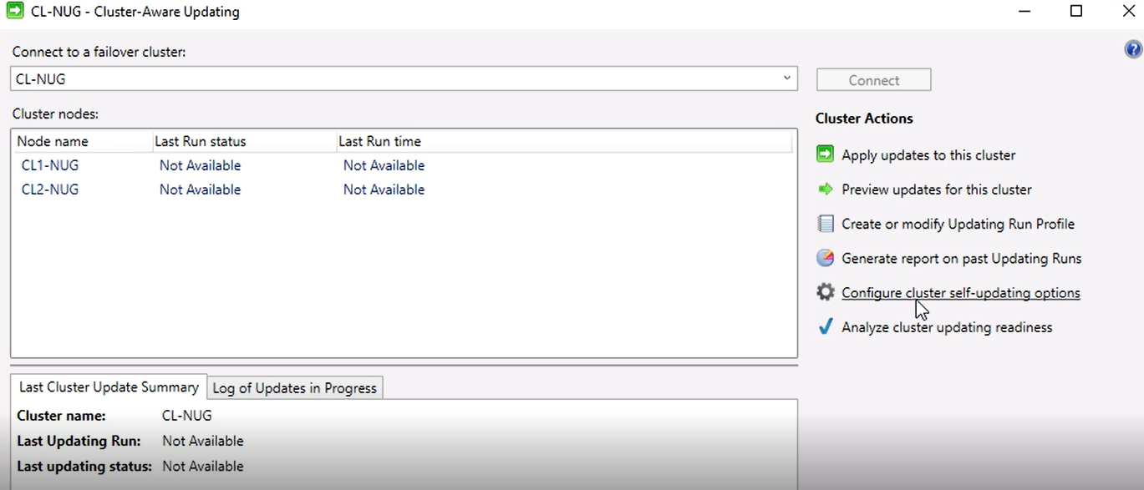

And Set for update schedule

Powershell

* Add-CauClusterNode
* Invoke-CauRun (manually trigger updating)

Apply updates to this cluster

Cluster OS upgrage to server2016 without downtime

(only for HyperV or Scale-out cluster)

2016 daki tüm özelliklerden faydalanabilmek için tüm node’ların 2016 ya geçmesi gerekir

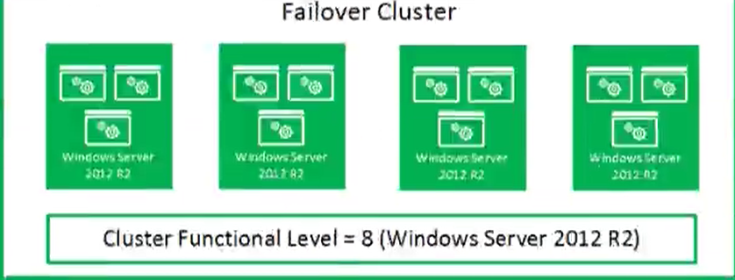

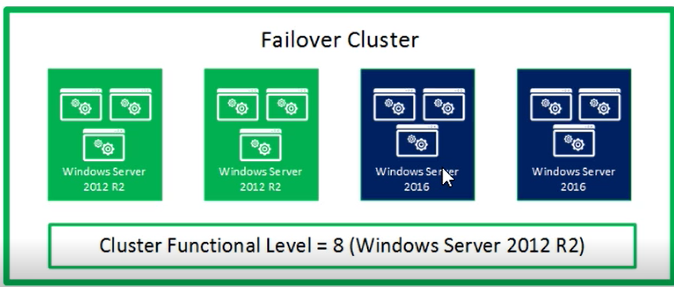

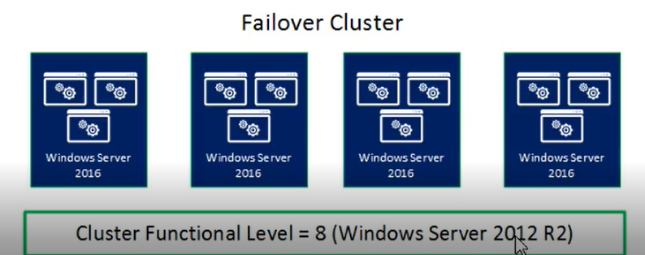

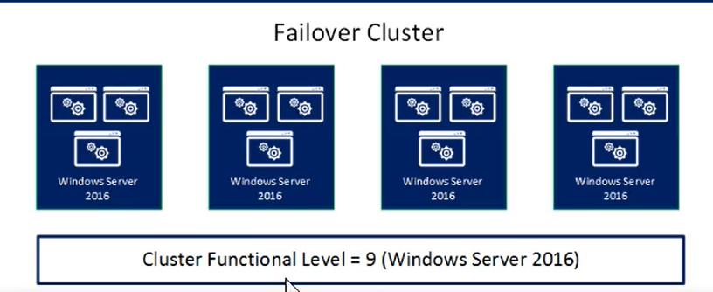

Cluster OS upgrading

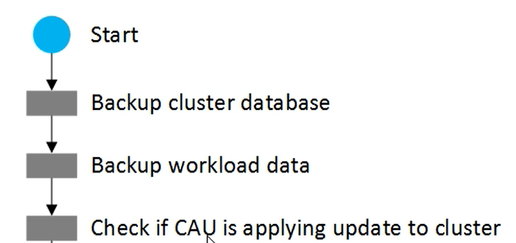

(disable self updating)

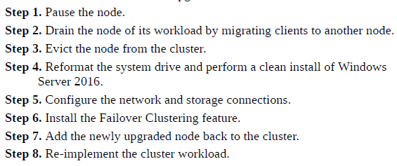

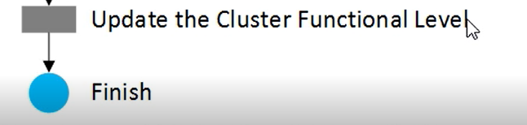

Disable self updating

Disable-CauClusteredNode -Clustername <clustername> -Force

Pause node and drain roles

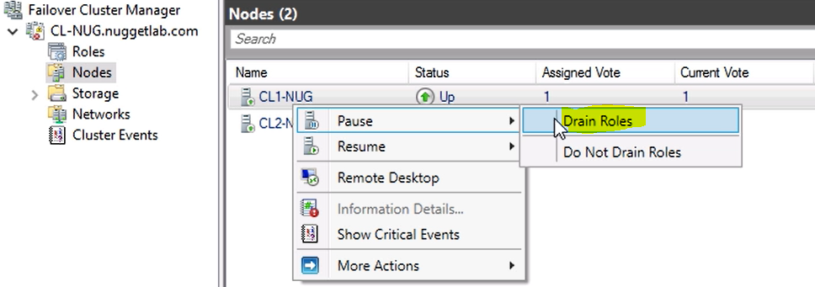

**Suspend-ClusterNode**

Evict node from cluster

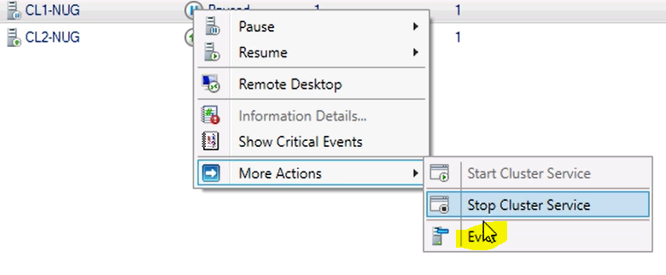

Add node to the cluster

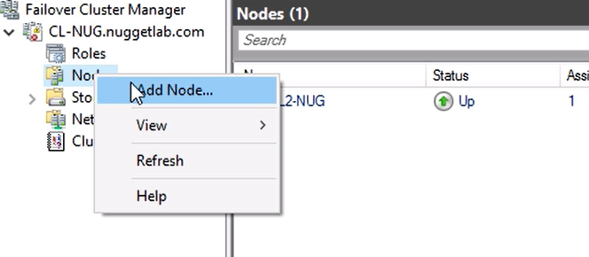

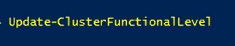

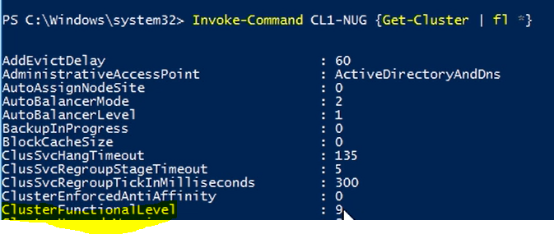

restore single node or cluster configuration

windows server backup cant perform backup of Clustered Shared Volumes but can back up databases of cluster

Authoritive-non authoritive

Authoritive (e.x)

Wbadmin strart systemstatebackup –backuptarget: d:

Wbadmin get versions

Wbadmin get items –version:<dateofbackup>

Wbadmin start systemstaterecovery –version: :<dateofbackup> ###non authoritive

### authoritive



configure clusters without network names

AD-detached cluster



implement VM resiliency

VM states

**Unmonitored**: Shows that the VM owning a role is not watched by the cluster service

**Isolated**: Shows that the node is not an active member of the cluster but is still in possession of a role

**Quarantine**: Shows a node that has been drained of its roles and removed from the cluster for a specified length of time after having left and reentered the cluster three times in the previous hour

Powershell

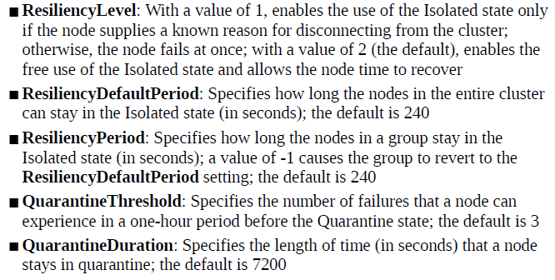

CLUSER STORAGE

Shared Storage Options

* Fibre Channel
* Serial Attached SCSI (SAS)
* iSCSI

Clustered Share Volumes

Add available Disk to cluster > >

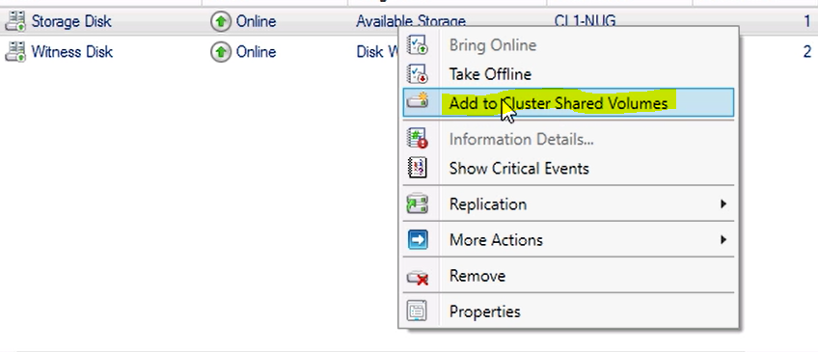



CSV mounts on C:\ClusterStorage on all cluster nodes.

FAILOVER CLUSTER ROLES

Add cluster role>

* Dfs namespace server
* Dhcp server
* Distributed transaction coordinator
* File server
* Generic application
* Generic script
* Generic service
* Hyperv replica broker
* Iscsi target server

Bu roller node’larda olmalıdır

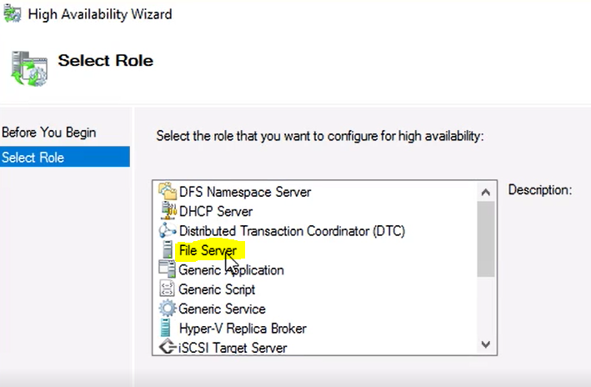

**Distributed Transaction Coordinator (DTC):** Supports distributed applications that perform transactions

**Generic Application:** Offers high availability for certain applications that were not designed to run on a cluster

**Generic Script:** For scripts that run in the Windows Script Host to control applications, you can enable high availability using this role

**Generic Service:** Offers high availability for certain services that were not designed to run in a cluster

**Hyper-V Replica Broker:** Permits the participation of the cluster in Hyper-V Replica

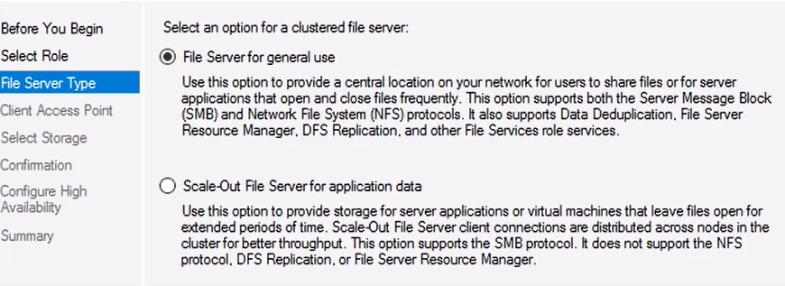

File server for general use> user data (other nodes waiting for fail over) share is only available in one node> active-passive

Her role için yeni cluster IPsi verilir!!

Scale-out File Servers> active-active >> all nodes accesses data >application data (SQL,HYPERV clusters)

Any node can process disk read and write requests.

Client Access point: NAME

Dns records (ips of two nodes)



Kullanacagın diskte

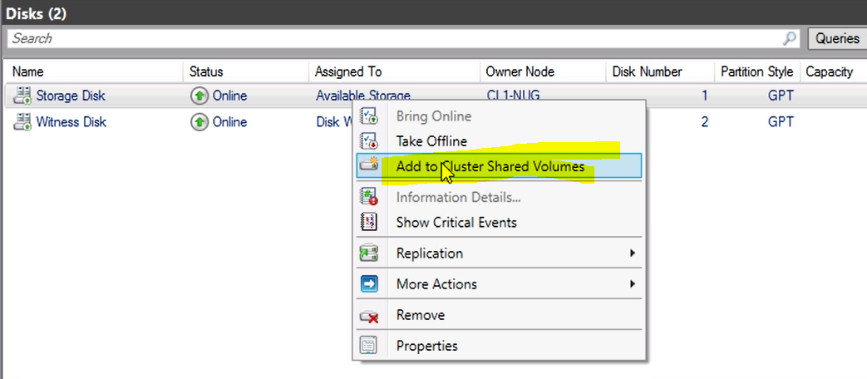

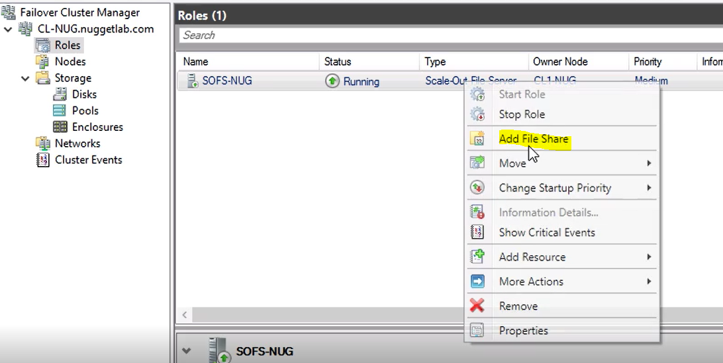

File Share type: SMB Share for applications

Disk: CSVE

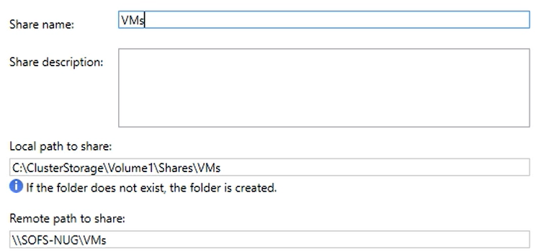

Give Permissions to share

Available paths

Disc coordinator: CL1-NUG







Cont regular file server

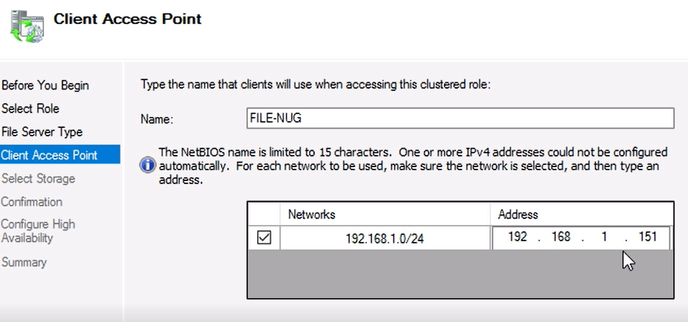

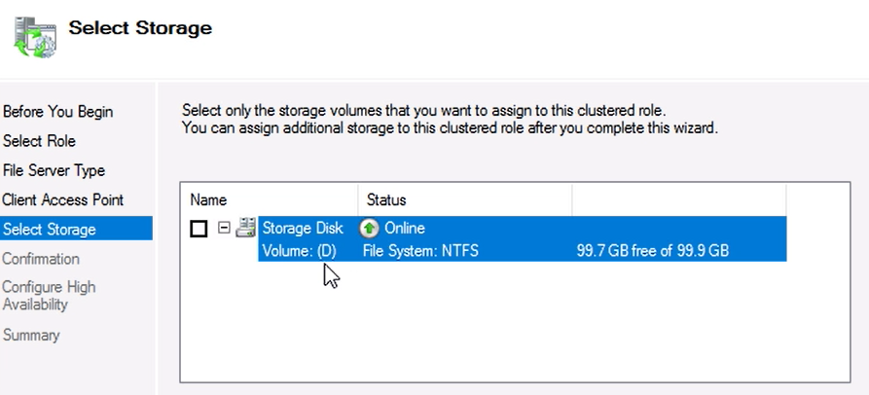

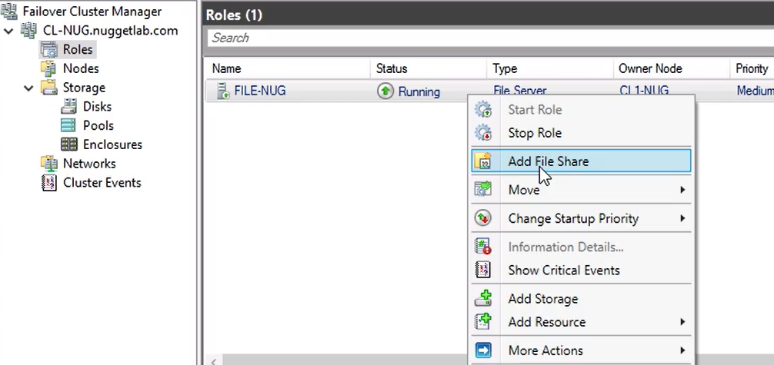

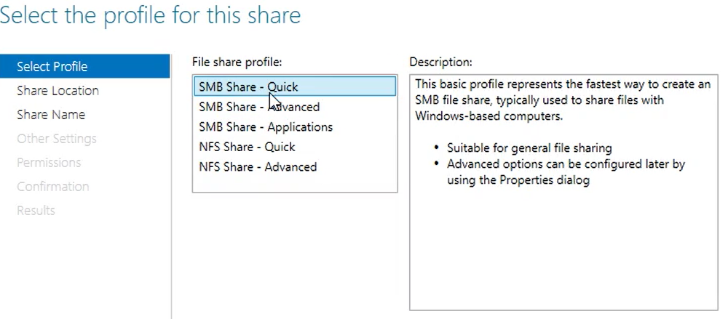

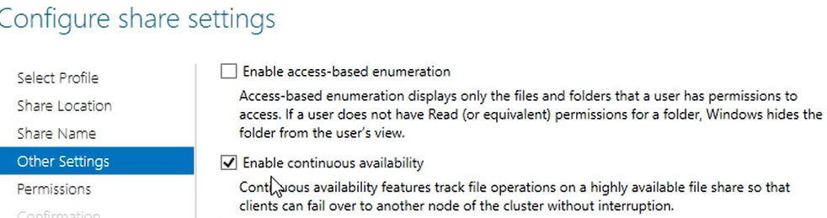

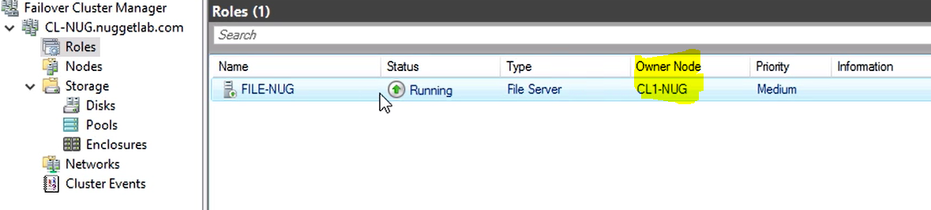

**& MANAGING FAILOVER CLUSTERING**

Failover Setings

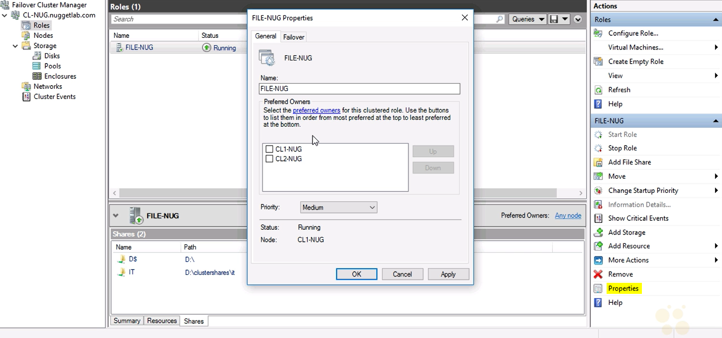

specify the node you would prefer to run the role

Priority drop-down list, you can specify High, Medium, or Low to indicate when the role should start in relation to the other roles in the cluster.

Failover tab, you can specify the maximum number of times the cluster should try to restart a role or fail it over to another node during the time interval specified by the Period setting.

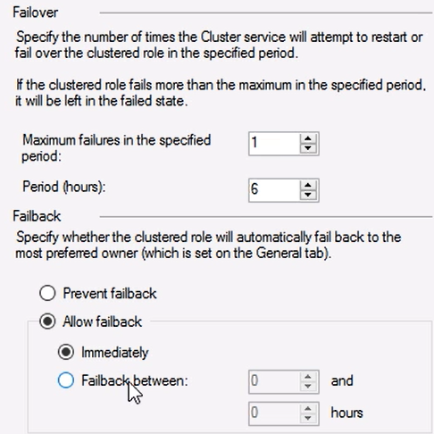

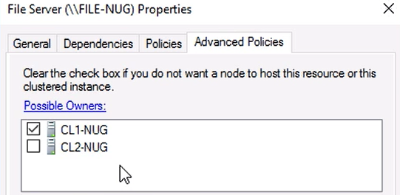

If CL1 down, it will fail over to cl2 in stopped state

Role>> Show Dependency Report

Changing owner

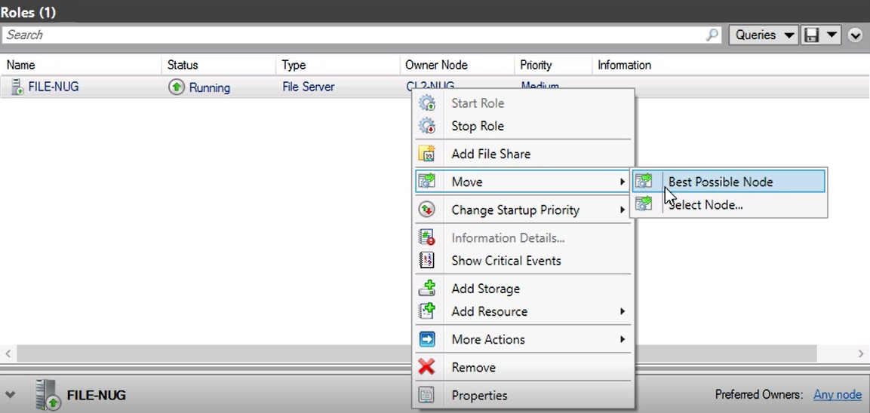

implement a Clustered Storage Spaces solution using Shared SAS storage enclosures

use storage pool, create volume and attach to cluster as CSV

Implementing Storage Replica

shared VHDX file on the physical cluster’s CSVs.

HYPERV CLUSTER

There is no need to manually configure the Hyper-V server to enable Live Migration or select an authentication protocol.

Network: Company network so that VMs are member of domain

Creating VM

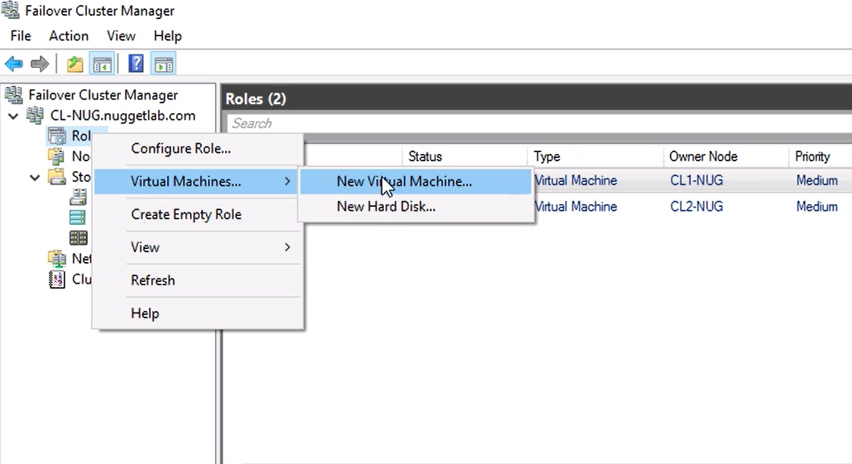

VM disk and config location : CSVE

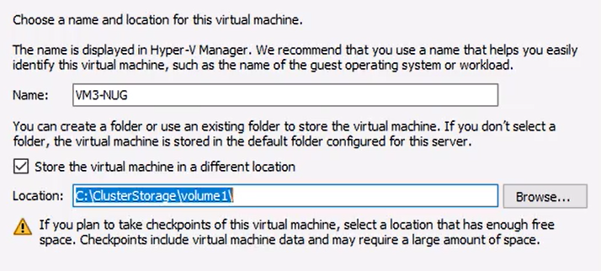

Add-ClusterVirtualMachineRole >> creates a clustered virtual machine, that is, a virtual machine that can be failed over if necessary to a different server in the failover cluster.

e.x Move-ClusterVirtualMachineRole "Virtual Machine1" -Node node2 >> Live Migration

Live Migration and Quick Migration does not move data files

Data files should be placed on shared storage, so the destination VM already has access to them

Live Migration

copies the memory directly from the source to the destination. (when VM is on)

Quick Migration

copies the VM’s memory first to disk and then from disk to the destination, pause VM before migrate(when VM is off)

Storage Migration

moves a VM’s virtual hard disk files but not its memory and system state.

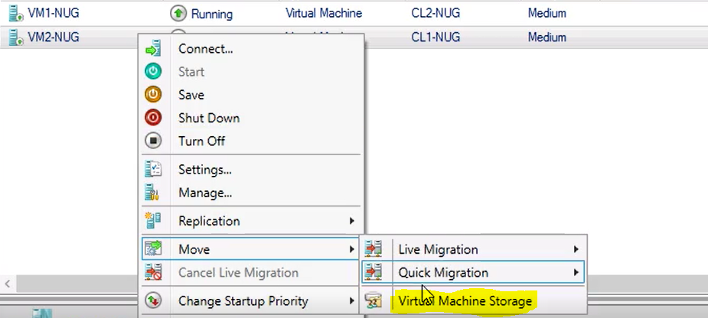

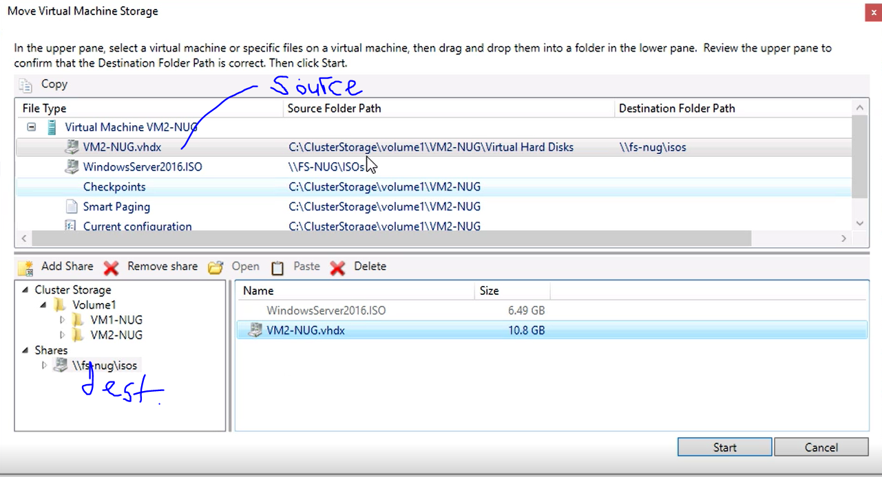

Importing-Copying VMs

Just like regular HyperV, failover does not effect

**Export-VM** -name myclustervm1 -path <sharedstorage> (from any nodes of cluster)

**Import-VM** -path "z:\vm\virtual machines\ 5ae40946-3a98-428e-8c83-081a3c68d17a.xml" -copy -generatenewid

VM Network Health Protection

What it does?

Network Health Protection is a feature that detects whether a VM on a cluster node has a functional connection to a designated network. If it does not, the cluster automatically live migrates the VM role to another node (enabled by default)

Control when it starts?

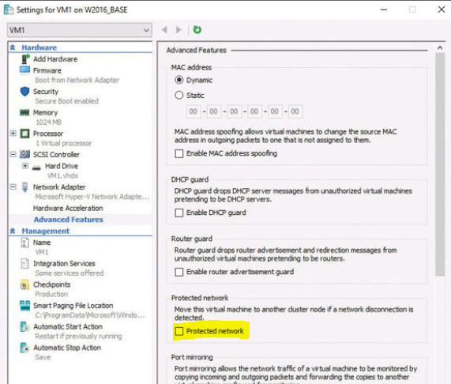

Clear checkbox >> prevent live migrations to occur due to shortage

Configuring drain on shutdown

Before shutdown select the node and clicking Pause and then Drain Roles

Drain on Shutdown, which automatically live migrates all the roles on a node before shutting down the system.

(enabled by default)

**(Get- Cluster).DrainOnShutdown** command. The value **1** indicates that the feature isenabled, and **0** indicates disabled.

VM monitoring

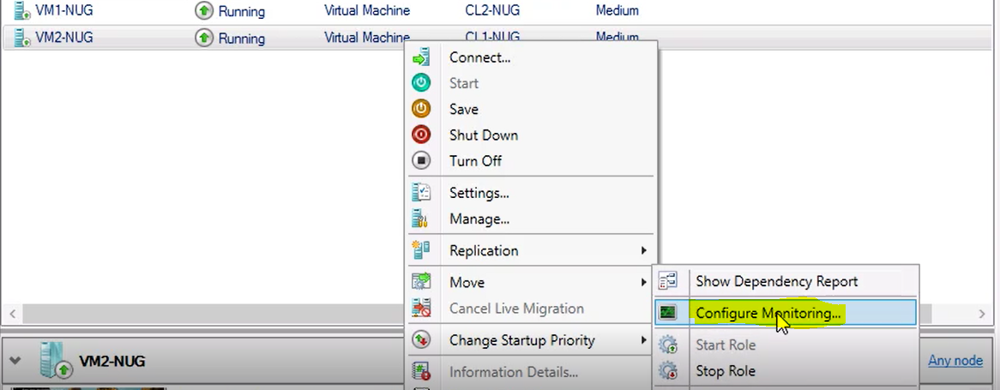

VM üzerindeki servislerin durması halinde services konsolundaki aksiyonu alır

determine usage scenarios for implementing guest clustering

VHD-set

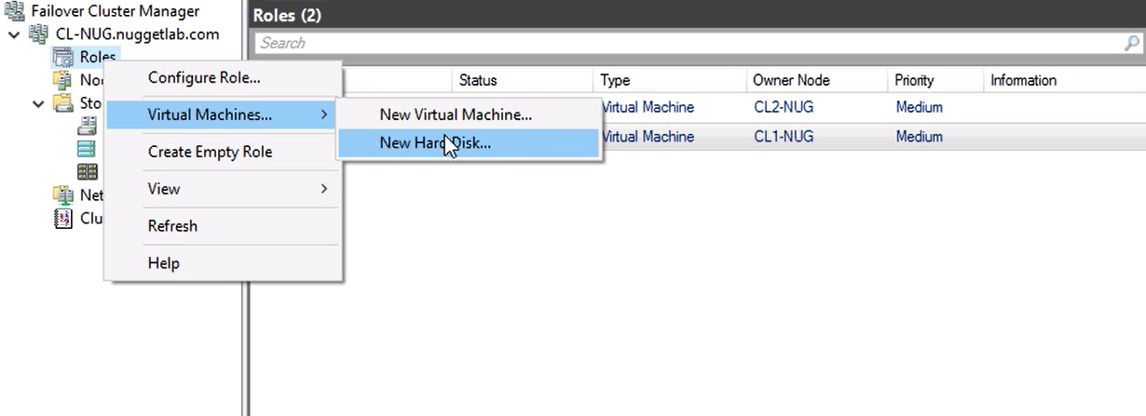

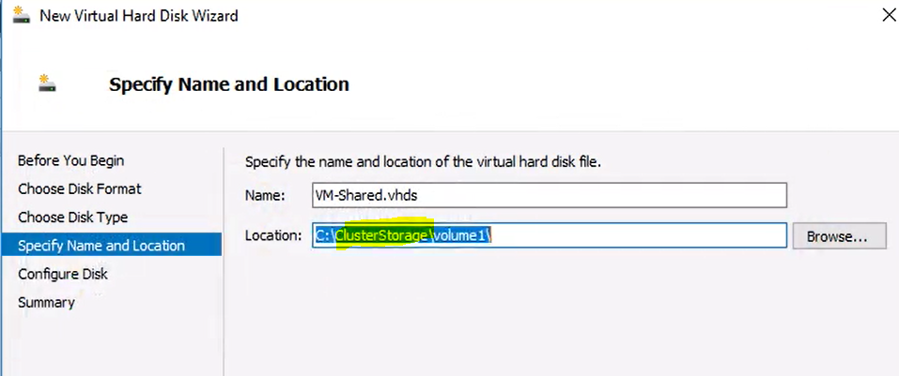

For both VM

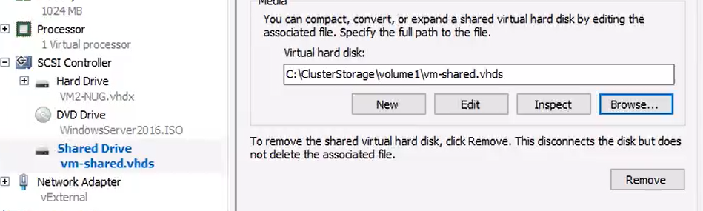

From one of VM> create volume from VHDset

Identical VMs running on single host

Install failover-clustering role and similar steps as physical machines

Usage scenarios

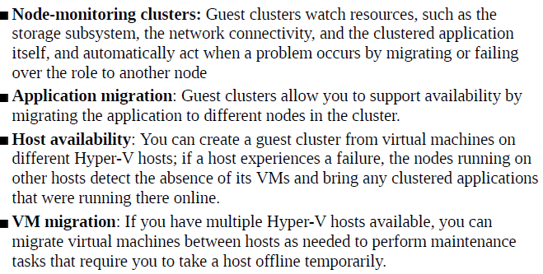

Node fairness

to balance the distribution of workloads between nodes in a cluster.

Yüke göre VM’leri otomatik taşımak (enabled by default)

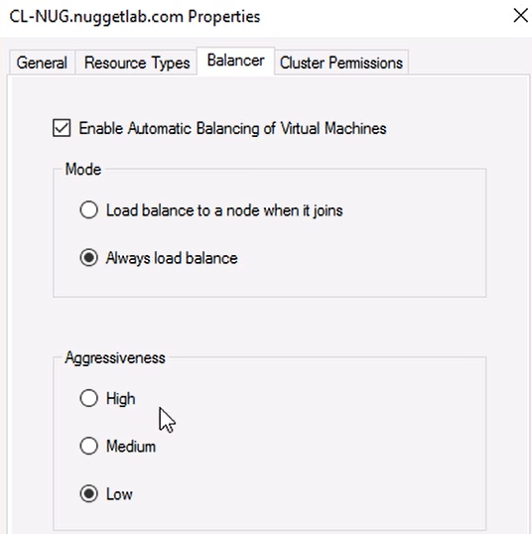

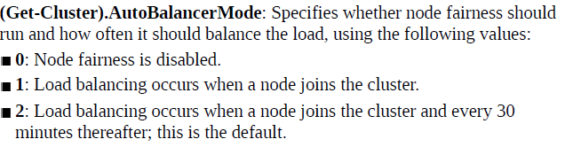

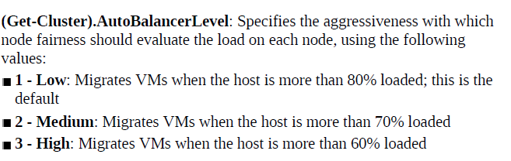

**AutoFailbackType**

**0=prevents failback**

1=allows failback



The failover threshold is the number of times the group can fail over within the number of hours specified by the failover period.

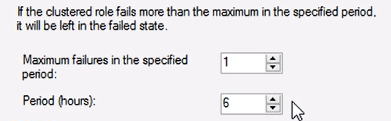

**Priority>>**

High (3000)

Medium (2000): The default setting

Low (1000)

No Auto Start (0)

No Auto Start value is used typically for non-production virtual machines; these are machines that you do not want to start up after a cluster failover occurs so that you can prevent these virtual machines from consuming resources.

Strech-Cluster

Storage Replica to sync data between sites.

Nodes try to fail over to the same site until there are no more nodes at the local site. Failover then targets other sites.

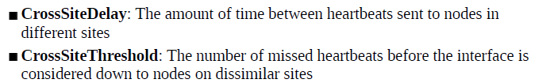

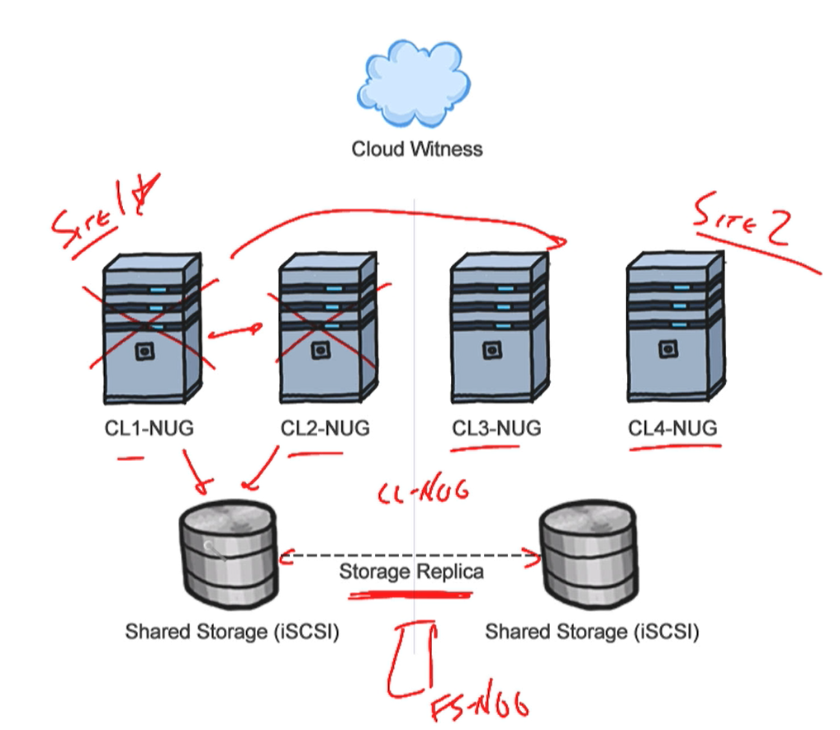

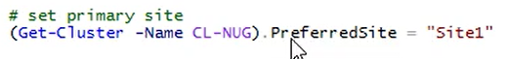

**VM resiliency>>**

Unmonitored

İsolated

Quarantine

Resiliency Level>

2 always go isolated state,

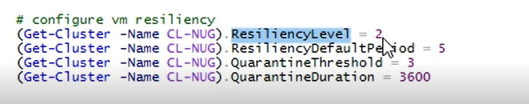

**STORAGE SPACE DIRECT**

For HyperV clusters

**Reqs**

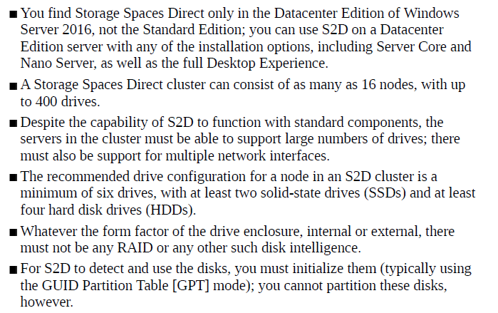

Locally attached software defined storage

Disaggregated cluster>

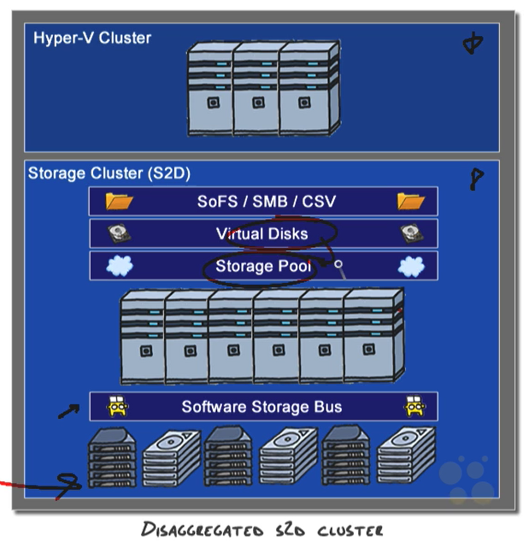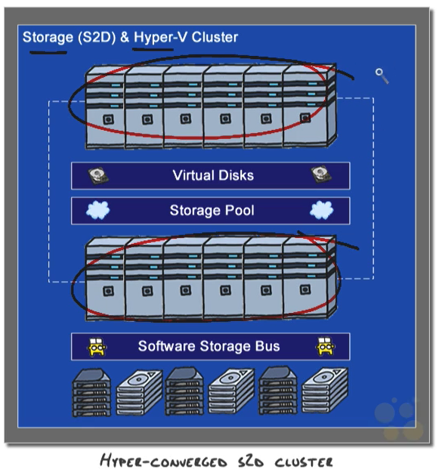Hyper Converged Cluster>

Disaggregated>>Scale- Out File Server cluster that uses Storage Spaces Direct. This cluster provides the storage for a second cluster. This is a Hyper-V cluster hosting virtual machines.





(add the storage when you enable Storage Spaces Direct)







**NETWORK LOAD BALACING**

* It can consist of 2 to 32 servers (hosts).
* Each host runs a separate copy of the desired application
* As traffic increases, it is possible to add hosts to the cluster to increase its capacity.
* NLB hosts exchange messages called *heartbeats* once a second. Heartbeats are critical, allowing hosts to track the availability of other hosts; when the heartbeats from a single host stop for a given length of time, the other hosts remove that host from the cluster
* Any time a cluster adds or removes a host, the NLB cluster performs a process known as *convergence*. During convergence, the cluster evaluates current cluster membership and determines how the cluster should distribute client requests.
* NLB can be configured to automatically add a host to the cluster if that cluster host fails and is subsequently brought back online. The added host can start handling new server requests from clients.
* NLB hosts need not be identical.
* All the hosts in an NLB cluster must be connected to the same subnet.
* All hosts in an NLB cluster must have static IP addresses.



Form a cluster

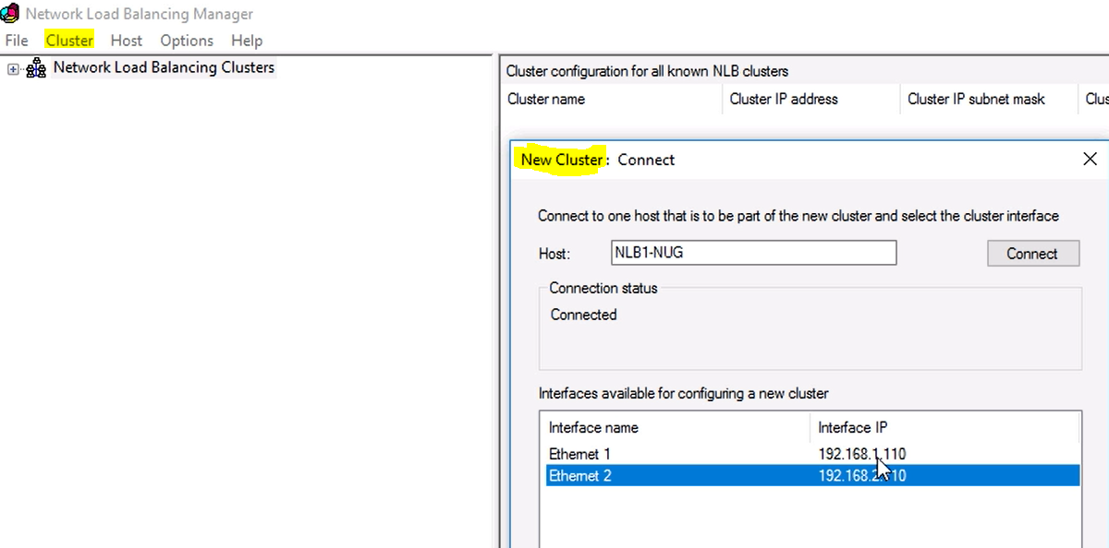

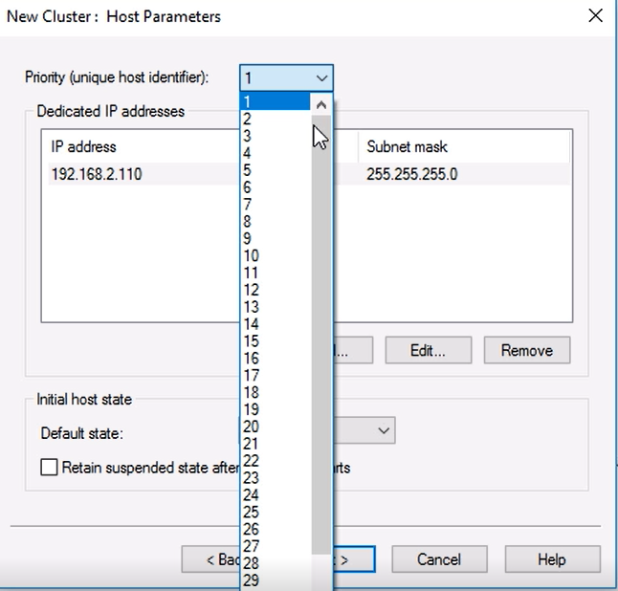

This value must be unique on each host you install; any traffic that does not conform to the port rules configured for the cluster will be forwarded to the host with the lowest priority value

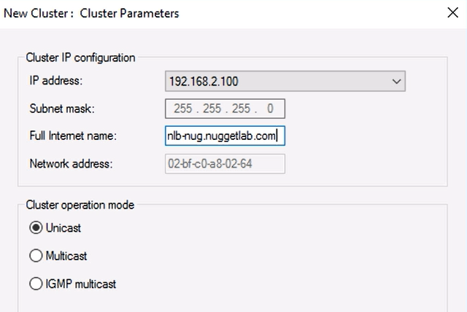

Unicast>> 2 network interface card

Multicast>> 1n network interface card

IGMP multicast>>

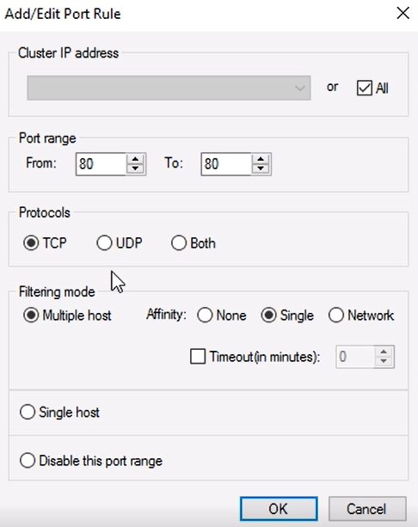

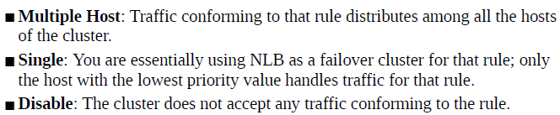

Affinity

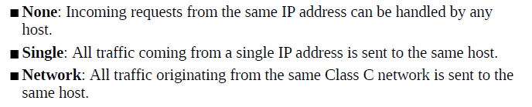

Timeout check box to specify the maximum amount of time that can pass between connections before the affinity rule no longer applies.

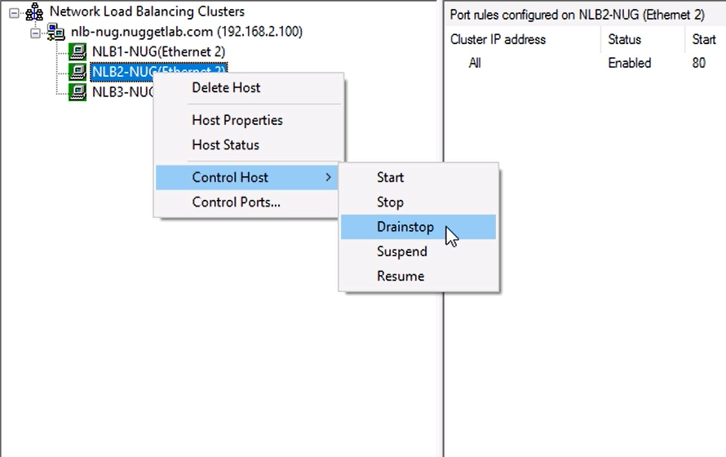

Drainstop> dont allow any more incoming connection but keep existing

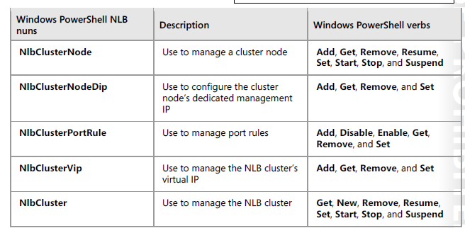

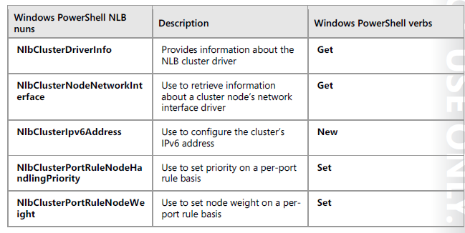

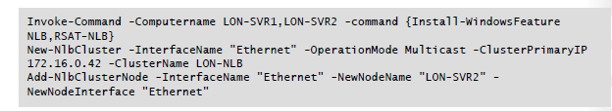

Failover Cluster Cmdlets

Suspend-Clusternode > Pausing (suspending) a node is usually done when applying software updates to the node, where the recommended sequence is to move all services and applications off of the node, pause the node, then apply software updates to the node

Suspend-Clusterresource> applies to disks and Cluster Shared Volumes only.

e.x Suspend-ClusterResource "Cluster Disk 2"

StopClusterresource,ResumeClusterResource

Stop-ClusterResource "IP Address 172.24.11.0"

Stop-CLusterGroup

Stop-ClusterGroup FileServer1 > takes the clustered file server (resource group) called FileServer1 offline on the local cluster.

Set-ClusterResourceDependency cluster1FS12 "[IP Address 151.56.48.0]"

Set-ClusterQuorum -NodeAndDiskMajority "Cluster Disk 7"

Set-ClusterQuorum -NodeAndFileShareMajority \\fileserver\fsw

Set-CauClusterRole -ClusterName CONTOSO-FC1 -DaysOfWeek Tuesday -WeeksOfMonth 1,2 -RebootTimeoutMinutes 10 -Force

**Add-ClusterCheckpoint** cmdlet adds a cryptographic key checkpoint or registry checkpoint for a resource.

Get-ClusterAvailableDisk | Add-ClusterDisk

Add-ClusterFileServerRole -Storage "Cluster Disk 6" -Name cluster1FS12

>  creates a clustered file server using Cluster Disk 6, and assigns the name cluster1FS12.

Add-Clustergroup>> A resource group (a clustered service or application) is the unit of failover. During failover, all resources in the resource group move together.

Add-ClusterServerRole -Storage "Cluster Disk 4","Cluster Disk 5" -Name MainSrv2

>creates a clustered service or application using Cluster Disk 4 and Cluster Disk 5, and assigns the name MainSrv2.

Get-ClusterGroup cluster1FS12 | Get-ClusterResource | Get-ClusterResourceDependency

 displays the dependencies for each resource in the clustered file server

Virtual disk cmdlets

Get-VirtualDisk | Where-Object -Filter { $_.OperationalStatus -eq "Detached" } | Connect-VirtualDisk }

CommandType Name ModuleName

----------- ---- ----------

Alias Expand-IscsiVirtualDisk IscsiTarget

Function Add-VirtualDiskToMaskingSet Storage

Function Connect-VirtualDisk Storage

Function Disconnect-VirtualDisk Storage

Function Get-VirtualDisk Storage

Function Get-VirtualDiskSupportedSize Storage

Function Hide-VirtualDisk Storage

Function New-StorageSubsystemVirtualDisk Storage

Function New-VirtualDisk Storage

Function New-VirtualDiskClone Storage

Function New-VirtualDiskSnapshot Storage

Function Remove-VirtualDisk Storage

Function Remove-VirtualDiskFromMaskingSet Storage

Function Repair-VirtualDisk Storage

Function Resize-VirtualDisk Storage

Function Set-VirtualDisk Storage

Function Show-VirtualDisk Storage

Cmdlet Add-IscsiVirtualDiskTargetMapping IscsiTarget

Cmdlet Checkpoint-IscsiVirtualDisk IscsiTarget

Cmdlet Convert-IscsiVirtualDisk IscsiTarget

Cmdlet Dismount-IscsiVirtualDiskSnapshot IscsiTarget

Cmdlet Export-IscsiVirtualDiskSnapshot IscsiTarget

Cmdlet Get-IscsiVirtualDisk IscsiTarget

Cmdlet Get-IscsiVirtualDiskSnapshot IscsiTarget

Cmdlet Import-IscsiVirtualDisk IscsiTarget

Cmdlet Mount-IscsiVirtualDiskSnapshot IscsiTarget

Cmdlet New-IscsiVirtualDisk IscsiTarget

Cmdlet Remove-IscsiVirtualDisk IscsiTarget

Cmdlet Remove-IscsiVirtualDiskSnapshot IscsiTarget

Cmdlet Remove-IscsiVirtualDiskTargetMapping IscsiTarget

Cmdlet Resize-IscsiVirtualDisk IscsiTarget

Cmdlet Restore-IscsiVirtualDisk IscsiTarget

Cmdlet Set-IscsiVirtualDisk IscsiTarget

Cmdlet Set-IscsiVirtualDiskSnapshot IscsiTarget

Cmdlet Stop-IscsiVirtualDiskOperation IscsiTarget

Shielded vm template disk

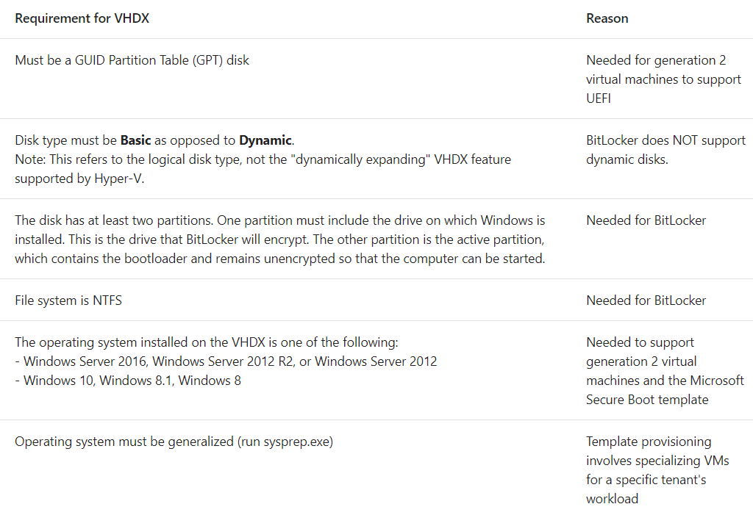

**VM version**

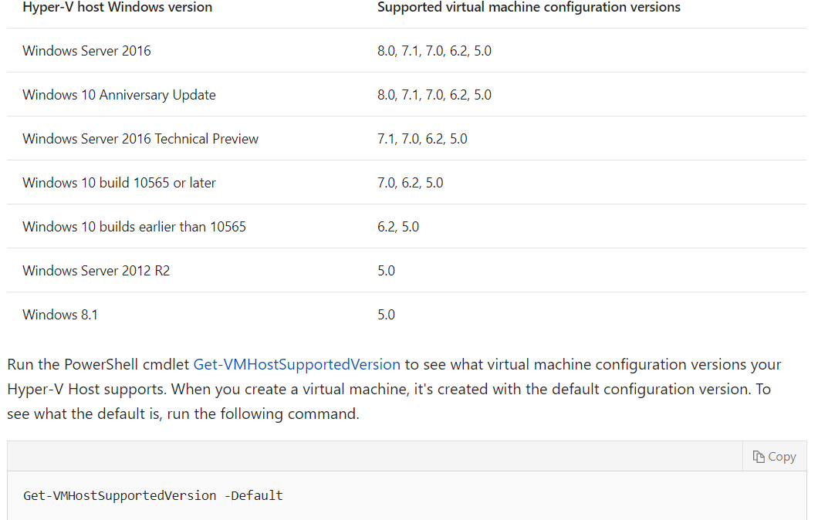

When you move or import a virtual machine to a computer that runs Hyper-V on Windows Server 2016 or Windows 10, the virtual machine"s configuration isn't automatically updated.

you can't use some of the new virtual machine features until you manually update the configuration version. You can't downgrade the virtual machine configuration version after you've upgraded it.